LIGHTING CONTROLS

Generally, lighting management will be carried out by presence and brightness detectors. The type, the number, the brightness, and time delay adjustment values ​​will be adapted to the premises and to the controlled lighting sources. Circuits will be properly subdivided so that only dark areas are lit during the day. All detectors must be adjustable by remote control.

Principles of operation and material requirements

1- Circulation, Halls, Stairwells Management:
Automatic operation by presence and luminosity detector on 2/3 of the lighting, 1/3 on a control system not accessible to the public allowing compliance with EC6.1 regulations

Typical detector PD4-M-1C-Corridor + Slaves in ceiling mounting (recessed or surface-mounted depending on the nature of the ceiling) of the BEG LUXOMAT brand or technically equivalent and will have the following characteristics:
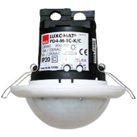
Degree / protection class: SM: IP54 with base, FC: IP20/Class II/CE
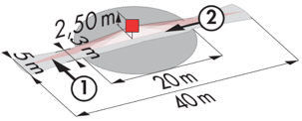
Detection area: h=2,50 m: 40 x 5 m across, 20 x 3 m towards, Ø 8 m vertical
Switching power: 2300W cos φ 1/1150VA cos φ 0.5, LED 300W maxi
Follow-up time: 30 s to 30 min or pulse / Brightness: 10 to 2000 Lux
Permanent control of daylight and artificial light
Applications: Circulations

LC Plus 280° wall-mounted detector of the brand BEG LUXOMAT or technically equivalent and will have the following characteristics:

Degree / protection class: IP54/Class II/CE
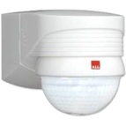
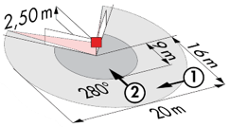
Detection area: h=2,50 m: 16 m across, 9 m towards, 2 m vertical
Switching power: 2000W cos φ 1/1000VA cos φ 0.5, LED 250W maxi
Follow-up time: 15 s to 16 min or pulse / Brightness: 2 to 2500 Lux
Applications: Stair

2- Management of Small Rooms, Airlocks, and Sanitary facilities:
Automatic operation by presence and luminosity detector

Detector type PD3N-1C for ceiling mounting (flush-mounted or surface-mounted depending on the nature of the ceiling) of the brand BEG LUXOMAT or technically equivalent and will have the following characteristics:

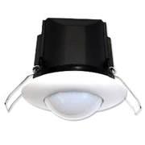
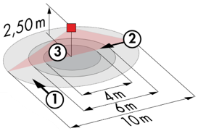
Protection class: SM: IP44, FC: IP23/Class II/CE
Detection area h=2.50 m: Ø 10 m across, Ø 6 m towards, Ø 4 m activity seat
Switching power: 2300W cos φ 1/1150VA cos φ 0.5, LED 300W max
Follow-up time: 30 s to 30 min or pulse / Brightness: 10 to 2000 Lux
Applications: Small rooms, airlocks, sanitary facilities

3- Parking Management:
Automatic operation by presence detector on DALI dimmable luminaires. The lighting management system will control a maximum surface area of 500m² per level and will ensure that the lighting is lowered to the minimum regulatory threshold when the area is unoccupied. The lighting on each level can be forced on and off from the porter's lodge.

Detector type PD4N-M-DACO-DALI 2 + Slaves for ceiling mounting (recessed or surface mounting depending on the nature of the ceiling) of the brand BEG LUXOMAT or technically equivalent and will have the following characteristics:

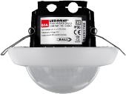
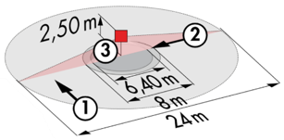
Protection class: SM: IP54 with surface-mounted accessory, FC: IP20/Class II/CE
Detection area h=2.50 m: Ø 24 m across, Ø8 m towards, Ø6,40 m seated
Interface: DALI 2 certified, digital driver control in broadcast mode
Follow-up time: 1 to 150 min or pulse / Brightness: 10 to 2500 Lux
Daylight-dependent constant dimming / 40 digital DALI drivers
Settings: Via bi-directional BEG-One smartphone application (read/write)
Applications: Car park circulation, Parking spaces

