LIGHTING CONTROLS

Generally, lighting management will be carried out by presence and brightness detectors. The type, the number, the brightness, and time delay adjustment values ​​will be adapted to the premises and to the controlled lighting sources. Circuits will be properly subdivided so that only dark areas are lit during the day. All detectors must be adjustable by remote control.

Principles of operation and material requirements

1- Circulation, Halls, Stairwells Management:
Automatic operation by presence and luminosity detector on 2/3 of the lighting, 1/3 on a control system not accessible to the public allowing compliance with EC6.1 regulations

Detector type PD4-M-1C-Corridor + Slaves in ceiling mounting (recessed or surface-mounted depending on the nature of the ceiling) of the BEG LUXOMAT brand or technically equivalent and will have the following characteristics:
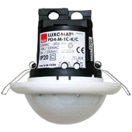
Degree / protection class: SM: IP54 with base, FC: IP20/Class II/CE
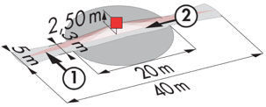
Detection area: h=2,50 m: 40 x 5 m across, 20 x 3 m towards, Ø 8 m vertical
Switching power: 2300W cos φ 1/1150VA cos φ 0.5, LED 300W maxi
Follow-up time: 30 s to 30 min or pulse / Brightness: 10 to 2000 Lux
Permanent control of daylight and artificial light
Applications: Circulations

Detector type PD4-M-1C + Slaves in ceiling mounting (recessed or surface-mounted depending on the nature of the ceiling) of the BEG LUXOMAT brand or technically equivalent and will have the following characteristics:
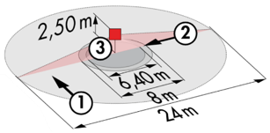
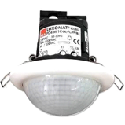
Degree / protection class: SM: IP54 with base, FC: IP20/Class II/CE
Detection area: h=2,50 m: Ø 24 m across, Ø 8 m towards, Ø 6,40 m activity seat
Switching power: 2300W cos φ 1/1150VA cos φ 0.5, LED 300W maxi
Follow-up time: 30 s to 30 min or pulse / Brightness: 10 to 2000 Lux
Permanent control of daylight and artificial light
Applications: Halls

Detector type LC Plus 280° wall-mounted detector of the brand BEG LUXOMAT or technically equivalent and will have the following characteristics:

Degree / protection class: IP54/Class II/CE
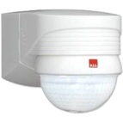
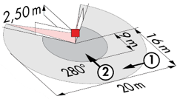
Detection area: h=2,50 m: 16 m across, 9 m towards, 2 m vertical
Switching power: 2000W cos φ 1/1000VA cos φ 0.5, LED 250W maxi
Follow-up time: 15 s to 16 min or pulse / Brightness: 2 to 2500 Lux
Applications: Stair

2- Small rooms Management:
Automatic operation by presence and luminosity detector

Detector type PD3N-1C for ceiling mounting (flush-mounted or surface-mounted depending on the nature of the ceiling) of the brand BEG LUXOMAT or technically equivalent and will have the following characteristics:

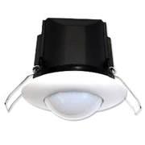
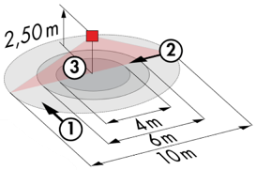
Protection class: SM: IP44, FC: IP23/Class II/CE
Detection area h=2.50 m: Ø 10 m across, Ø 6 m towards, Ø 4 m activity seat
Switching power: 2300W cos φ 1/1150VA cos φ 0.5, LED 300W max
Follow-up time: 30 s to 30 min or pulse / Brightness: 10 to 2000 Lux
Applications: Sanitary / Cloakrooms / Technical rooms / Airlocks...

3- Operating principles of the rooms:
- Bathroom management
Automatic operation by presence and luminosity detector IP65
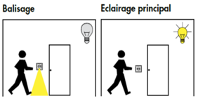
- Orientation lighting management
Automatic operation by presence and luminosity detector. The beaconing will allow the nurse carrying out his rounds or the resident to bring an orientation light in case of detection
- Entrance lighting management
Semi-automatic operation by absence and luminosity detector. A push button, integrated in the detector, will allow the entrance lighting to be switched on manually and voluntarily. Only the extinction will be automatic

Detector type PD9-M-1C-IP65-FC for flush ceiling mounting, brand BEG LUXOMAT or technically equivalent, with the following characteristics:
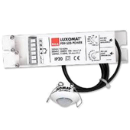
Protection class: Detection head: IP65/Class III/CE, Power supply IP20/Class II/CE
Detection area h=2.50 m: Ø 10 m across, Ø6 m towards, Ø4 m seated
Switching power: 2300W cos φ 1/1150VA cos φ 0.5, LED 300W max
Follow-up time: 15 s to 30 min or pulse / Brightness: 10 to 2000 Lux
Application: Bathrooms / Showers

Detector type Indoor 140L for wall flush mounting, installation height 1.10 m of the brand BEG LUXOMAT or technically equivalent and will have the following characteristics:
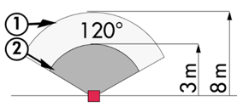
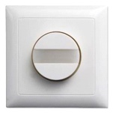
Protection class: FM: IP20/Class II/CE,
Detection zones h=1.10 m: 8 m across, 3 m towards
Switching power: 2000W cos φ 1/1000VA cos φ 0.5, LED 250W max
Follow-up time: 15 s to 30 min or pulse / Brightness: 10 to 2000 Lux
Functions: Beaconing / Night light. Integrated push button for manual control of the lighting
Application: Orientation lighting / Entrance lighting

4- Conference Room Management:
Semi-automatic operation by absence detector on DALI dimmable luminaires. The lighting located near the windows will be controlled independently of the lighting on the corridor side to take account of natural light. The lighting will be switched on manually and voluntarily by pressing the push button. Only the variation, considering the natural light, and the extinction will be automatic. The PB will also allow the user to manually control the lighting, allowing him to temporarily force the state of the luminaires to be switched on, off and dimmed. The system will also offer the possibility of creating lighting scenarios, for example for conferences or projections. Commissioning and modifications will be carried out via a dedicated smartphone application in BLE (Bluetooth) communication with the system. This will be carried out by the contractor or by a manufacturer's commissioning service.

The principle chosen will be the DALI-LINK brand BEG LUXOMAT or technically equivalent, comprising the following equipment:

- DALI BUS power supply type PS-DALI-LINK-100mA with the following characteristics:
Main’s supply 230V AC / DALI BUS supply 16V DC / 100 mA / 300m BUS max
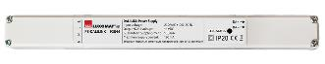
Auto-addressing of components on the BUS
Control of up to 25 DALI luminaires and 6 control devices
(Multi sensors/ PB interfaces…)
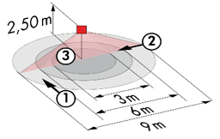
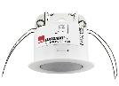
8 control zones maximum per power supply / 16 groups / 16 scenes

- Multi DALI sensors with the following characteristics:
Power supply and communication via DALI BUS 16V DC
Protection class: IP20/Class 2
Functions: Master / Slave / Switching or Control / Lighting sensor
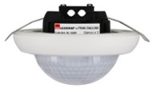
Type PD11-DALI-LINK
Detection area h=2,50 m: Ø 9 m across, 6 m towards, 3 m activity seat
Type PD4N-DALI-LINK
Detection area h=2,50 m: Ø 24 m across, 8 m towards, 6,40 m activity seat

- DALI PB interface type PBM-DALI-LINK-4W-BLE with the following characteristics:
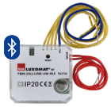
Power supply and communication via DALI BUS 16V DC
Bluetooth communication for setting up
4 independently interfaceable binary inputs
Can be combined with all manufacturers’ pushbuttons
Variant without Bluetooth: PBM-DALI-LINK-4W
