1- Principle of the system

An intelligent lighting management system will be installed in the premises concerned, ensuring that the sources are completely switched off when unoccupied. This solution will enable lighting to be managed according to the amount of natural light coming in, up to 2 groups (1st day/2nd day), to ensure a constant illumination threshold, to give the user the possibility of taking control of the lighting in "temporary derogation" mode and to create lighting scenarios. The user will call up the scenarios by push button. The principle is based on an Addressable DALI BUS. Commissioning and modifications will be carried out via a dedicated Smartphone application in BLE (Bluetooth) communication with the system. It will be the responsibility of the contractor or the manufacturer's commissioning service.

2- Description of the equipment making up the system

The principle retained will be the DALILINK of the brand BEG LUXOMAT or technically equivalent comprising the following equipment:

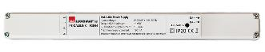
  - DALI BUS power supply type PS-DALI-LINK-100mA with the following characteristics:
- 230V AC mains supply / DALI BUS supply 16V DC / 100mA / 300m BUS max
- Self-addressing of the components on the BUS
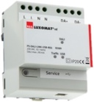
- Control of up to 25 DALI luminaires and 6 control devices
(Multi sensors/ BP interfaces...)
- Possibility of doubling the power supply to control up to 50 DALI luminaires and 12 control devices
- Up to 8 control zones per supply / 16 groups / 16 scenes
- Modular variant: PS-DALILINK-USB-REG-210mA
Control of up to 45 DALI luminaires and 10 control devices
(Multi sensors/ PB interfaces...)
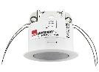
2.2- Multi DALI sensors with the following characteristics:
- Power supply and communication via DALI BUS 16V DC
- Ultra-flat PIR sensor type PD11-DALILINK-FLAT-FC
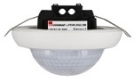
Range at 2.50 m installation height: Ø 9 m across, Ø6 m towards, Ø3 m seated
Protection class IP20 / Class 2/CE
- PIR long range sensor type PD4N-DALILINK-SM/FC
Range at 2.50 m installation height: Ø 24 m across, Ø 8 m towards, Ø 6,40 m seated
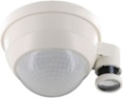
Protection class IP20 / Class 2/CE
- PIR high-bay sensor type PD4-DALILINK-GH-SM
Range at 10 m installation height: Ø 30 x Ø 19 m towards
Protection class IP54 / Class 2/CE

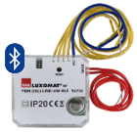
- DALI PB interface type PBM-DALI-LINK-4W-BLE with the following characteristics:
Power supply and communication via DALI BUS 16V DC
Bluetooth communication for setting up
4 independently interfaceable binary inputs
Can be combined with all manufacturers’ pushbuttons
Variant without Bluetooth: PBM-DALI-LINK-4W

3- System functions and architecture

- “Presence" sensor function: AUTOMATIC switching on, dimming and switching off
- “Absence" sensor function: MANUAL switching on, dimming and AUTOMATIC switching off
- “SOFT start" function: gradual lighting up
- “Override" function: short presses "On / Off", long presses "Dimming +/-".
- “1st day / 2nd day" function: Management of lighting in 2 groups "corridor side / window side" by negative offset (-x%)
- “Scenes" function: Up to 16 configurable scenes called up by push button
- “Stairwell" function: Manual switch-on via push button, time-delayed switch-off from 1 to 150 minutes / advance notice of switch-off
- “Guided Light" function: Intelligent switching of sources and anticipation of people's movements
