LIGHTING CONTROLS

The building will be equipped with a GTB allowing the control of various technical units either by local, automatic, or centralized controls. The system will ensure modularity of operation according to the activities carried out, conference, projection, etc., and should be scalable to anticipate a possible extension to new installations. The principle will be based on a KNX BUS. Commissioning and modifications will be carried out via the dedicated programming software "ETS", connected locally via a KNX/IP interface or via a WEB interface on the LAN or WLAN network and will be carried out by a KNX certified integrator.

The system will allow, via a supervision, a complete control of the installations, a visualization of status and the reception of information for maintenance.

Through the components connected to the BUS, this solution will provide the following functions:

1- Lighting management
A lighting management system will be installed in each lecture theatre, allowing the light sources to be completely switched off when unoccupied or when there is sufficient natural light in the room. The system will be composed of presence sensors, digital switching TOR or DALI dimming actuators depending on the nature of the luminaires, associated with a "KNX" type control panel

- Occupancy management by presence detection
- Dimming of lighting, constant light threshold
- Main lighting of the lecture hall divided into at least 2 groups: 1st day / 2nd day
- Lecturer lighting Management
- Board Management or screen lighting
- Override Management of the different lighting circuits (On / Off / Dimming)
- Lighting Scenarios Management (Conference, Projection...)
- Re-lighting in the event of a fire

2- Air change management
The air renewal of each room will be controlled automatically, considering the occupation of the room and the quality of the ambient air. Information on room occupancy will be sent to the HVAC package via presence sensors and information on air quality via a VOC sensor (Volatile Organic Compounds).

3- Temperature management
Each room will be equipped with a temperature sensor and a presence sensor, associated with a weather station and an annual time circuit according to the occupation of the building. The temperature of each room can be adapted to the information retrieved on the KNX bus (temperature increase in advance in case of extreme cold, reduced temperature at night…). By customer request, it will be possible, in each room, to increase or decrease the temperature set point by +/-2°C by means of the thermostat located locally.

4- Shutter and sunshade management
The control of the sunshades and roller shutters will be carried out automatically by the BMS or locally by “KNX” type pushbuttons located in each permanently occupied room (offices, meeting rooms…). The common areas will be controlled solely by the BMS. A KNX weather station will be connected to the system to control the brises soleil according to the weather outside.

The KNX system selected will be of the brand BEG LUXOMAT or technically equivalent, comprising the following equipment

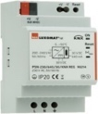
- KNX power supply type PSN-230/640/30-KNX-REG
230V AC / 30V DC BUS KNX / 640mA/ 1000m BUS max
Integrated choke to supply the bus with constant and stabilized current
Up to 64 participants on the KNX BUS (Multi-sensors / PB interfaces / Actuators…)

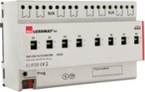
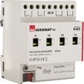
- Switching actuator “TOR” type SA4/8/230/16/H/KNX REG
Power supply via KNX BUS
Outputs: 4 (SA4) or 8 (SA8) 16 A switching outputs
Current measurement possible with actuator type SA4/8-230/16/H/EM/KNX REG
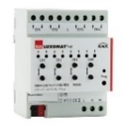
- KNX blind actuator type SBA4-230/10/H/KNX REG
Power supply via KNX BUS
Control of 4 AC motors 230 V max. 600 W
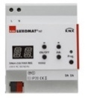
- DALI/KNX Gateway type DA64-230/KNX REG
Power supply 230V AC – Communication via KNX BUS
DALI BUS supply for 64 luminaires in 16 groups / 16 scenes
Support for RGB and TW (Tunable White – DALI Type 8)
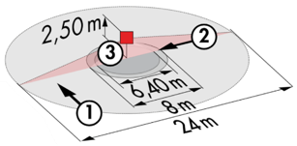
- KNX multi-sensor type PD4-KNX-SONT/DX
Power supply and communication via KNX BUS
Area zone h=2.50m: Ø24 m oblique, Ø 8 m towards, Ø 6,40 m seated
Protection class IP20/Class 2/CE
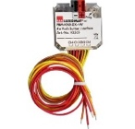
- KNX PB interface type BP-KNX-DX-4W
Power supply and communication via KNX BUS
Up to 4 pushbuttons as imput
Can be combined with all manufacturers’ pushbuttons
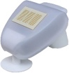
- KNX Weather Station type KNX-WTS-GPS
Power supply and communication via KNX BUS
Wind, Rain, Dusk, Temperature and Light Sensors

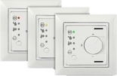
- VOC sensor type WS-VOC-HVAC-KNX
Power supply and communication via KNX BUS
Temperature sensors, room thermostat, VOC sensor (Volatile Organic Compounds)
Humidity Sensor and CO₂ Sensor

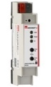
- KNX Router and IP interface
Power supply and communication via KNX BUS
Router LK-IP/KNX-REG: Enables the transfer of telegrams between different KNX segments via a LAN (IP)
LAN-IF/KNX-REG IP interface: Connection of a PC for addressing via LAN bus, programming, and diagnostics of KNX components

