1- Principle of the system

The premises concerned will be equipped with a lighting management system with adjustable whites that simulates the natural cycle of the sun (Circadian Lighting). This solution, equipped with a presence detector, will ensure that the lighting is switched on, dimmed according to the natural light input, and completely switched off in the event of unoccupation. The colour temperature change profile will be adapted to the application (Classroom, EHPAD Nursing Home, Office...). The system will also allow the user to temporarily control the switching on/off and dimming of the luminaires but not to change the colour temperature.
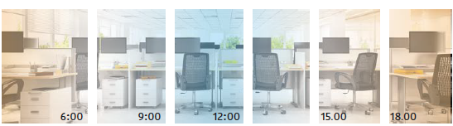

2- System equipment specifications

The selected system will be based on HCL (Human Centric Lighting) from BEG LUXOMAT or technically equivalent equipped with an autonomous presence sensor (integrated HCL BUS controller) and DALI DT8 "Tunable White" luminaires.

2.1- HCL detector type PD4-M-HCL2 with "Tunable White" function + Slaves for ceiling mounting (flush or surface mounted depending on the nature of the ceiling) with the following characteristics:

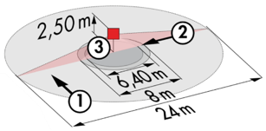
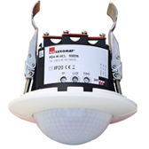
Protection class: SM: IP54 with base, FC: IP20/Class II/CE
Detection area h=2.50 m: Ø 24 m across, Ø 8 m towards, Ø 6,40 m seated
Presence detector with: Power supply, DALI BUS controller and HCL
Real time clock
DALI zone segmented into 3 groups with constant offset control (Groups 1 to 3)
Follow-up time: 5 to 120 min or pulse / Brightness: 10 to 2000 Lux
Daylight-dependent constant dimming / 64 DALI DT8 digital drivers
Applications: Classrooms / Lounges / Offices

2.2- LED lights with adjustable whites’ (Tunable White) type PL1-600-LED-AG-DALI-TW for recessed ceiling mounting with the following characteristics:

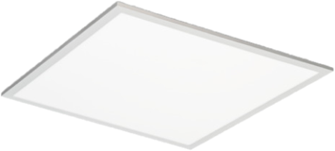
Voltage: 200 - 240 V AC 50 Hz / Output: 45 W / 3550 lm
Colour temperature adjustable from 2700K (warm white) to 6500K (daylight)
Variable luminous flux depending on colour temperature
(2700K = 3150lms - 70 lm/W / 6500K = 3550lms - 79 lm/W)
Luminaire: Single LED Stage / Lifetime: > 40,000 Hours / L80B50
Drivers: DALI DT8 type / Colour temperature control
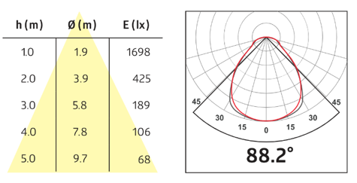
Glare: UGR < 19 / Micro-prismatic
Photobiological risk: RG0 (risk-free)
Colour rendering index: CRI 80
SDCM (Standard Deviation Colour Matching): Mac Adam 3
Protection class: IP 20 / Class II/CE
Ambient temperature: -20°C to + 40°C
Type of installation: Mounting in suspended ceiling 600x600 mm
Dimensions: 595 x 595 x 10 mm
Frame: Aluminium

