LIGHTING CONTROLS

Generally, lighting management will be carried out by presence and brightness detectors. The nature of the detectors, the number, the brightness, and time delay adjustment values ​​will be adapted to the premises and to the controlled lighting sources. Circuits will be properly subdivided so that only dark areas are lit during the day. All detectors must be adjustable by remote control.

Principles of operation and material requirements

1- Exteriors Management, Small Premises, Parking:
Automatic operation by presence and light sensor

LC Plus 280° wall-mounted detector of the brand BEG LUXOMAT or technically equivalent and will have the following characteristics:
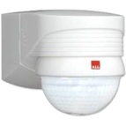
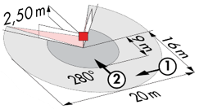
Degree / protection class: IP54/Class II/CE
Detection area: h=2,50 m: 16 m across, 9 m towards, 2 m vertical
Switching power: 2000W cos φ 1/1000VA cos φ 0.5, LED 250W maxi
Follow-up time: 15 s to 16 min or pulse / Brightness: 2 to 2500 Lux
Applications: Outdoor

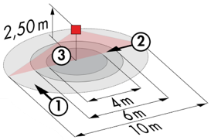
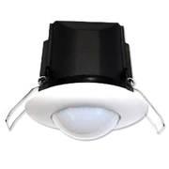
Typical detector PD3N-1C for ceiling mounting (recessed or surface-mounted depending on the nature of the ceiling) of the BEG LUXOMAT brand or technically equivalent and will have the following characteristics:

Degree / protection class: IP44, FC: IP54/Class II/CE
Detection area: h=2,50 m: Ø 10 m across, 6 m towards, 4 m seated
Switching power: 2300W cos φ 1/1150VA cos φ 0.5, LED 300W maxi
Follow-up time: 30 s to 30 min or pulse / Brightness: 10 to 2500 Lux
Applications: Toilets / Lockers rooms / Equipment rooms / Airlocks…

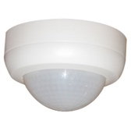
Typical detector PD4N-1C-SM for surface mounting on the ceiling of the BEG LUXOMAT brand or technically equivalent and will have the following characteristics:
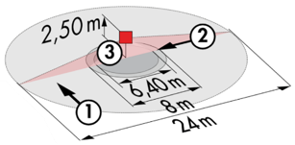
Degree / protection class: SM: IP44
Detection area: h=2,50 m: Ø 24 m across, 8 m towards, 6,40 m seated
Switching power: 2300W cos φ 1/1150VA cos φ 0.5, LED 300W maxi
Follow-up time: 30 s to 30 min or pulse / Brightness: 10 to 2000 Lux
Applications: Parking

2- Offices Management, Trays Offices and Meeting Rooms, Circulation and Stairwells:
The lighting management will be based on DALI2 technology, according to IEC 62386 standard. The DALI bus will be used to connect luminaires and presence detectors via controllers or bus interfaces connected to the BMS. The management system will automatically dim the lighting to consider the natural light inflow and will allow the light sources to be completely switched off when unoccupied. This solution will offer the possibility of easily modifying the partitions, without intervention on the luminaires or the wiring, and will have to be evolutionary allowing to anticipate a possible extension to new installations. Each luminaire will be addressed individually, to report the status and defects of each device to the supervision system.

Through the components connected to the BUS, this solution will provide the following characteristics:

2.1- Management of Offices, Trays Office, and Meeting Rooms
- Occupancy management by presence or absence detection / Lighting variation, constant lighting threshold
- User overrides by local PB or by "wireless" interface
- Creation of lighting scenarios and/or atmospheres in the meeting rooms for projection or videoconferencing
- Control of air renewal and temperature by information from presence sensors to the HVAC unit
- GTB link

2.2- Management of Circulation and Stairwells
- Occupancy management by presence and luminosity detection
- Lowering to the minimum regulatory threshold in case of unoccupation
- In the stairwells, this solution will ensure a level-by-level operation
- BMS link

The selected sensors will be " Multi-Master " on DALI 2 protocol of BEG LUXOMAT brand or technically equivalent and will have the following technical characteristics:

- Multi-sensor DALI type PDx-BMS-DALI2
DALI Multi-Master technology according to IEC 62386, part 103
Compatible with DALI 2 controllers according to IEC 62386 part 101/103/304. Section 0 provides information on room assignment and motion detection on the DALI bus according to IEC 62386 part 303. Section 1 provides the LUX values on the DALI bus according to IEC 62386 part 304. Parameterization is possible via a multi-master application controller from any manufacturer on DALI 2 protocol.
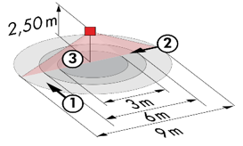
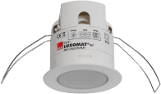
PD11-BMS-DALI2-FC: Ø 9 m across, Ø 6 m towards, Ø 3 m seated
Applications: Offices / Trays Offices
PD4N-BMS-DALI2-SM/FC: Ø 24 m across, Ø 8 m towards, Ø 6,40 m seat activity
Applications: Meeting rooms / Halls / Parking
PD4N-BMS-DALI2-C SM/FC: 40 x 5 m across, 20 x 3 m towards, Ø 8 m vertical
Applications: Circulation
LC-Mini-120°-BMS-DALI2: 12 m across, 3 m towards
Applications: Stairs
