LIGHTING CONTROLS

Generally, lighting management will be carried out by presence and brightness detectors. The type, the number, the brightness, and time delay adjustment values ​​will be adapted to the premises and to the controlled lighting sources. Circuits will be properly subdivided so that only dark areas are lit during the day. All detectors must be adjustable by remote control.

Principles of operation and material requirements

1- Small Premises, Outdoor Management:
Automatic operation by presence and luminosity detector

LC Plus 280° wall-mounted detector of the brand BEG LUXOMAT or technically equivalent and will have the following characteristics:

Degree / protection class: IP54/Class II/CE
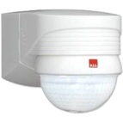
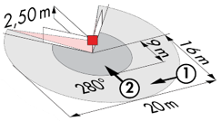
Detection area: h=2,50 m: 16 m across, 9 m towards, 2 m vertical
Switching power: 2000W cos φ 1/1000VA cos φ 0.5, LED 250W maxi
Follow-up time: 15 s to 16 min or pulse / Brightness: 2 to 2500 Lux
Applications: Stair / Waiting area

Detector type PD3N-1C for ceiling mounting (flush-mounted or surface-mounted depending on the nature of the ceiling) of the brand BEG LUXOMAT or technically equivalent and will have the following characteristics:

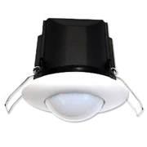
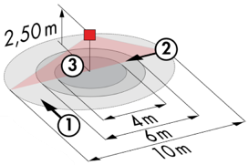
Protection class: SM: IP44, FC: IP23/Class II/CE
Detection area h=2.50 m: Ø 10 m across, Ø 6 m towards, Ø 4 m activity seat
Switching power: 2300W cos φ 1/1150VA cos φ 0.5, LED 300W max
Follow-up time: 30 s to 30 min or pulse / Brightness: 10 to 2000 Lux
Applications: Sanitary / Cloakrooms / Technical rooms / Airlocks...

2- Operating principles of the Rooms:
- Bathroom management
Automatic operation by presence and luminosity detector
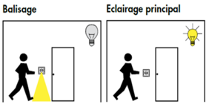
- Orientation lighting management
Automatic operation by presence and luminosity detector. The beaconing will allow the nurse carrying out his rounds or the resident to bring an orientation light in case of detection
- Entrance lighting management
Semi-automatic operation by absence and luminosity detector. A push button, integrated in the detector, will allow the entrance lighting to be switched on manually and voluntarily. Only the extinction will be automatic

Detector type PD9-M-1C-IP65-FC for flush ceiling mounting, brand BEG LUXOMAT or technically equivalent, with the following characteristics:
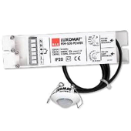
Protection class: Detection head: IP65/Class III/CE, Power supply IP20/Class II/CE
Detection area h=2.50 m: Ø 10 m across, Ø 6 m towards, Ø 4 m seated
Switching power: 2300W cos φ 1/1150VA cos φ 0.5, LED 300W max
Follow-up time: 15 s to 30 min or pulse / Brightness: 10 to 2000 Lux
Application: Showers

Detector type Indoor 140L for wall flush mounting, installation height 1.10 m of the brand BEG LUXOMAT or technically equivalent and will have the following characteristics:
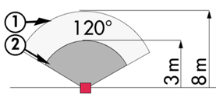
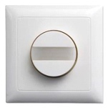
Protection class: FM: IP20/Class II/CE,
Detection zones h=1.10 m: 8 m across, 3 m towards
Switching power: 2000W cos φ 1/1000VA cos φ 0.5, LED 250W max
Follow-up time: 15 s to 30 min or pulse / Brightness: 10 to 2000 Lux
Functions: Beaconing / Night light. Integrated push button for manual control of the lighting
Application: Orientation lighting / Entrance lighting

3- Management of offices, corridors, stairwells, and lounges:
The lighting management will be based on DALI2 technology, according to IEC 62386 standard. The DALI bus will be used to connect luminaires and presence detectors via controllers or bus interfaces connected to the GTB. The management system will automatically dim the lighting to take account of natural light and allow the light sources to be switched off completely when unoccupied. Each luminaire will be addressed individually, to report the status and faults of each device to the supervision system.

Through the components connected to the BUS, this solution will provide the following functions:

3.1- Office management
- Occupancy management by presence or absence detection / Lighting variation, constant lighting threshold
- User" overrides by local PB or by "wireless" interface
- Creation of lighting scenarios and/or atmospheres in the meeting rooms for projection or videoconferencing
- Control of air renewal and temperature by information from presence sensors in the HVAC unit
- GTB link

3.2- Circulation management
- Occupancy management by presence and luminosity detection
- Lowering to the minimum regulatory threshold in case of unoccupation
- In the access corridors to the rooms:
Daytime operation: By time circuit, during the hours of public occupation in the building, in case of unoccupation, the lighting of the corridors will be switched on at the minimum regulatory value. By presence detection, switching on at the set value.
Night operation: By time circuit, outside the hours of public occupation in the building, the lighting of the corridors will be lowered to the minimum regulatory value, thus avoiding too much light entering the residents' rooms during the nurses' rounds.
- In the stairwells, this solution will ensure level-by-level operation
- GTB Link

3.2- Lounge management
- Occupancy management by absence detection / Lighting variation, constant lighting threshold
- Lighting segmented into at least 2 groups: Window side management, corridor side management
- User" overrides by local PB
- Creation of environment scenarios according to the activity carried out
- Control of air renewal and temperature by information from presence sensors in the HVAC unit
- GTB link

The selected sensors will be " Multi-Master " on DALI 2 protocol of BEG LUXOMAT brand or technically equivalent and will have the following technical characteristics:

- Multi-sensor DALI type PDx-BMS-DALI2
DALI Multi-Master technology according to IEC 62386, part 103
Compatible with DALI 2 controllers according to IEC 62386 part 101/103/304. Section 0 provides information on room assignment and motion detection on the DALI bus according to IEC 62386 part 303. Section 1 provides the LUX values on the DALI bus according to IEC 62386 part 304. Parameterization is possible via a multi-master application controller from any manufacturer on DALI 2 protocol.
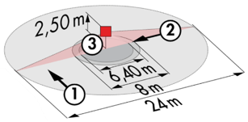
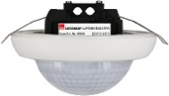
PD11-BMS-DALI2-FC: Ø 9 m across, Ø 6 m towards, Ø 3 m seated
Applications: Offices
PD4N-BMS-DALI2-SM/FC: Ø 24 m across, Ø 8 m towards, Ø 6,40 m seated
Applications: Halls / Lounges
PD4N-BMS-DALI2-C SM/FC: 40 x 5 m across, 20 x 3 m towards, Ø 8 m vertical
Applications: Circulation
LC-Mini-120°-BMS-DALI2: 12 m across, 3 m towards
Applications: Stairs
