LIGHTING CONTROLS

Generally, lighting management will be carried out by presence and brightness detectors. The nature of the detectors, the number, the brightness, and time delay adjustment values ​​will be adapted to the premises and to the controlled lighting sources. Circuits will be properly subdivided so that only dark areas are lit during the day. All detectors must be adjustable by remote control.

Principles of operation and material requirements

1- Small Premises Management
Automatic operation by presence and light sensor

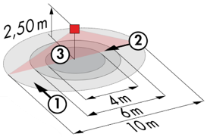
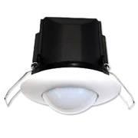
Typical detector PD3N-1C for ceiling mounting (recessed or surface-mounted depending on the nature of the ceiling) of the BEG LUXOMAT brand or technically equivalent and will have the following characteristics:

Degree / protection class: IP44, FC: IP54/Class II/CE
Detection area: h=2,50 m: Ø 10 m across, 6 m towards, 4 m activity seat
Switching power: 2300W cos φ 1/1150VA cos φ 0.5, LED 300W maxi
Follow-up time: 30 s to 30 min or pulse / Brightness: 10 to 2500 Lux
Applications: Toilets / Lockers rooms / Equipment rooms…

2- Building Technical Management:
The building will be equipped with a BMS allowing the control of different technical batches either by local, automatic, or centralized controls. The system will ensure the modularity of the installations, making it possible to easily modify the partitions, without having to intervene in the lighting or wiring, and will have to be scalable, making it possible to anticipate a possible extension to new installations. The principle will be based on a KNX BUS. Commissioning and modifications will be carried out via the dedicated “ETS” programming software, connected locally via a KNX/IP interface or via a WEB interface on the LAN or WLAN network and will be carried out by a KNX certified integrator. The system will allow, via a supervision, a complete control of the installations, a visualization of status and the reception of information for maintenance.

Through the components connected to the BUS, this solution will provide the following characteristics:

2.1- Lighting Management
A lighting management system will be installed in each room, allowing the light sources to be completely switched off when unoccupied or when there is sufficient natural light in the room. The system will be composed of presence sensors, digital switching or DALI dimming actuators depending on the nature of the luminaires, associated with local KNX push-button controls.

Car Park Management
- Occupancy management by presence and brightness detection
- Minimum dimming of lighting when an area is unoccupied, i.e., approximately 10% of the luminaire's power
- Switching on at the regulatory threshold by detecting the presence of a vehicle or person
- Lighting groups will be set up to control a maximum surface area of 500m².
- The lighting on each level can be forced on or off from the BMS

Circulation and Staircase Management
- Occupancy management by presence and luminosity detection
- Minimum dimming of lighting in case of unoccupied zone, i.e., about 10% of the luminaire power
- Switching on at the regulatory threshold by presence detection
- All corridors and stairwells can be forced to switch on or off from the BMS.

The KNX system selected will be of the brand BEG LUXOMAT or technically equivalent, comprising the following equipment

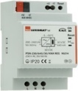
- KNX power supply type PSN-230/640/30-KNX-REG
230V AC / 30V DC BUS KNX / 640mA/ 1000m BUS max
Integrated choke to supply the bus with constant and stabilized current
Up to 64 participants on the KNX BUS (Multi-sensors / PB interfaces / Actuators…)

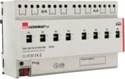
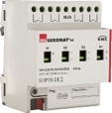
- Switching actuator “TOR” type SA4/8/230/16/H/KNX REG
Power supply via KNX BUS
Outputs: 4 (SA4) or 8 (SA8) 16 A switching outputs
Current measurement possible with actuator type SA4/8-230/16/H/EM/KNX REG
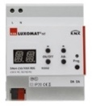
- DALI/KNX Gateway type DA64-230/KNX REG
Power supply 230V AC – Communication via KNX BUS
DALI BUS supply for 64 luminaires in 16 groups / 16 scenes
Support for RGB and TW (Tunable White – DALI Type 8)

- KNX multi-sensor type PDx-KNX-BA/ST/DX
Power supply and communication via KNX BUS
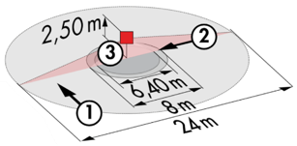
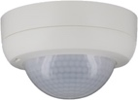
PD4-KNX-C SM/FC/FM (DX): 40 x 5 m across, 20 x 3 towards, Ø 8 m vertical
Applications: Circulation
PD4-KNX SM/FC/FM (BA-ST-DX): Ø 24 m across, Ø 8 m towards, Ø 6,40 m seated
Applications: Parking, Halls
RC-plus 230 KNX (DX): 20 m across, 6 m towards, 4 m vertical
Applications: Stairs / Sass

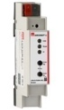
- KNX Router and IP interface
Power supply and communication via KNX BUS
Router LK-IP/KNX-REG: Enables the transfer of telegrams between different KNX segments via a LAN (IP)
LAN-IF/KNX-REG IP interface: Connection of a PC for addressing via LAN bus, programming, and diagnostics of KNX components

