LIGHTING CONTROLS

Generally, lighting management will be carried out by presence and brightness detectors. The nature of the detectors, the number, the brightness, and time delay adjustment values ​​will be adapted to the premises and to the controlled lighting sources. Circuits will be properly subdivided so that only dark areas are lit during the day. All detectors must be adjustable by remote control.

Principles of operation and material requirements

1- Small Rooms Management
Automatic operation by presence and light sensor

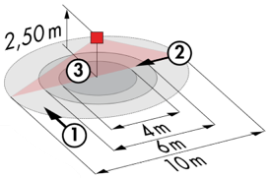
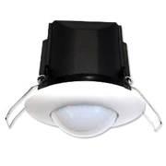
Typical detector PD3N-1C for ceiling mounting (recessed or surface-mounted depending on the nature of the ceiling) of the BEG LUXOMAT brand or technically equivalent and will have the following characteristics:

Degree / protection class: IP44, FC: IP54/Class II/CE
Detection area: h=2,50 m: Ø 10 m across, 6 m towards, 4 m activity seat
Switching power: 2300W cos φ 1/1150VA cos φ 0.5, LED 300W maxi
Follow-up time: 30 s to 30 min or pulse / Brightness: 10 to 2500 Lux
Applications: Toilets / Lockers rooms / Equipment rooms / Airlocks…

2- Building Technical Management:
The building will be equipped with a BMS allowing the control of different technical batches either by local, automatic, or centralized controls. The system will ensure the modularity of the installations, making it possible to easily modify the partitions, without having to intervene in the lighting or wiring, and will have to be scalable, making it possible to anticipate a possible extension to new installations. The principle will be based on a KNX BUS. Commissioning and modifications will be carried out via the dedicated “ETS” programming software, connected locally via a KNX/IP interface or via a WEB interface on the LAN or WLAN network and will be carried out by a KNX certified integrator. The system will allow, via a supervision, a complete control of the installations, a visualization of status and the reception of information for maintenance.

Through the components connected to the BUS, this solution will provide the following characteristics:

2.1- Lighting Management
A lighting management system will be installed in each room, allowing the light sources to be completely switched off when unoccupied or when there is sufficient natural light in the room. The system will be composed of presence sensors, digital switching or DALI dimming actuators depending on the nature of the luminaires, associated with local KNX push-button controls.

Office Management
- Occupancy management by absence detection / Lighting variation, constant lighting threshold
- User" overrides by local BP

Conference Room Management
- Occupancy management by absence detection / Lighting dimming, constant light threshold
- Lighting segmented into a minimum of 3 groups: Window side, corridor side and Table or Screen
- User" overrides via control panel or touch screen
- Creation of a projection scenario: switchboard lighting off, lowering of room lighting to 10%.

Management of Circulation, Halls and Stairwells
- Automatic switching on by the BMS at the minimum regulatory threshold. By presence detection and according to natural light, switching on at the set value.
- Forcing of state possible by the BMS

2.2- Air change management
The air renewal of each room will be controlled automatically, considering the occupation of the room and the quality of the ambient air. Information on room occupancy will be sent to the HVAC package via presence sensors and information on air quality via a VOC sensor (Volatile Organic Compounds).

2.3- Temperature management
Each room will be equipped with a temperature sensor and a presence sensor, associated with a weather station and an annual time circuit according to the occupation of the building. The temperature of each room can be adapted to the information retrieved on the KNX bus (temperature increase in advance in case of extreme cold, reduced temperature at night…). By customer request, it will be possible, in each room, to increase or decrease the temperature set point by +/-2°C by means of the thermostat located locally.

2.4- Shutter and sunshade management
The control of the sunshades and roller shutters will be carried out automatically by the BMS or locally by “KNX” type pushbuttons located in each permanently occupied room (offices, meeting rooms…). The common areas will be controlled solely by the BMS. A KNX weather station will be connected to the system to control the brises soleil according to the weather outside.

2.5- Conference room control panel

The local management of the various technical packages will be controlled either by a control panel or by means of a touch screen that includes the override of the various lighting circuits, the lighting scenarios for the Conference or Projection, the forcing of the temperature set point, the control of the ventilation, the BSO and the blinds.
The control panel will not be accessible to the public or, if touch screen, protected by a security code.

The KNX system selected will be of the brand BEG LUXOMAT or technically equivalent, comprising the following equipment

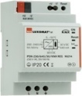
- KNX power supply type PSN-230/640/30-KNX-REG
230V AC / 30V DC BUS KNX / 640mA/ 1000m BUS max
Integrated choke to supply the bus with constant and stabilized current
Up to 64 participants on the KNX BUS (Multi-sensors / PB interfaces / Actuators…)

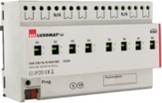
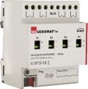
- Switching actuator “TOR” type SA4/8/230/16/H/KNX REG
Power supply via KNX BUS
Outputs: 4 (SA4) or 8 (SA8) 16 A switching outputs
Current measurement possible with actuator type SA4/8-230/16/H/EM/KNX REG
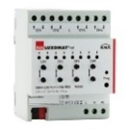
- KNX blind actuator type SBA4-230/10/H/KNX REG
Power supply via KNX BUS
Control of 4 AC motors 230 V max. 600 W
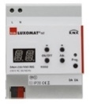
- DALI/KNX Gateway type DA64-230/KNX REG
Power supply 230V AC – Communication via KNX BUS
DALI BUS supply for 64 luminaires in 16 groups / 16 scenes
Support for RGB and TW (Tunable White – DALI Type 8)

- KNX multi-sensor type PDx-KNX-BA/ST/DX
Power supply and communication via KNX BUS
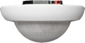
PD4-KNX-C SM/FC/FM (DX): 40 x 5 m across, 20 x 3 towards, Ø 8 m vertical
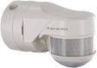
Applications: Circulation
PD4-KNX SM/FC/FM (BA-ST-DX): Ø 24 m across, Ø 8 m towards, Ø 6,40 m seated
Applications: Office / Meeting room / Halls
RC-plus 230 KNX (DX): 20 m across, 6 m towards, 4 m vertical
Applications: Stairs
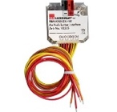
- KNX PB interface type BP-KNX-DX-4W
Power supply and communication via KNX BUS
Up to 4 pushbuttons as imput
Can be combined with all manufacturers’ pushbuttons
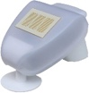
- KNX Weather Station type KNX-WTS-GPS
Power supply and communication via KNX BUS
Wind, Rain, Dusk, Temperature and Light Sensors

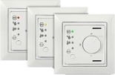
- VOC sensor type WS-VOC-HVAC-KNX
Power supply and communication via KNX BUS
Temperature sensors, room thermostat, VOC sensor (Volatile Organic Compounds)
Humidity Sensor and CO₂ Sensor

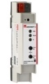
- KNX Router and IP interface
Power supply and communication via KNX BUS
Router LK-IP/KNX-REG: Enables the transfer of telegrams between different KNX segments via a LAN (IP)
LAN-IF/KNX-REG IP interface: Connection of a PC for addressing via LAN bus, programming, and diagnostics of KNX components
