LIGHTING CONTROLS

Intelligent lighting management will be installed in the amphitheaters, ensuring that the light sources are completely switched off when not in use. The system will ensure modularity of operation depending on the activity, conference, projection, etc., and should be scalable to allow for possible extension to new installations. The management principle will be based on DALI2 technology, to IEC 62386 standard. The DALI bus will be used to connect luminaires and presence detectors via controllers or bus interfaces connected to the GTB. Each luminaire will be addressed individually, to report the status and faults of each device to the supervision system.

The system is either stand-alone or can be linked to GTB system by interfacing the DALI protocol to the BACnet protocol.

Through the components connected to the BUS, this solution will provide the following functions

- Occupancy management by presence detection
- Dimming of lighting, constant light threshold
- Main lighting of the amphitheater segmented into at least 2 groups: 1st day / 2nd day
- Management of lecturer lighting
- Table Management or screen lighting
- By control panel not accessible to the public:
Override Management of the different lighting circuits (On / Off / Dimming)
Lighting Scenarios Management (Conference, Projection...)
- Control of air renewal by information from presence sensors to the HVAC unit
- Re-lighting in the event of a fire
- GTB Link

The sensor selected will be a "multi-Master" type on DALI 2 protocol from BEG LUXOMAT or technically equivalent and will have the following technical characteristics

- DALI multi-sensor type PDx-BMS-DALI2
DALI Multi-Master technology according to IEC 62386, part 103
Compatible with DALI 2 controllers according to IEC 62386 part 101/103/303/304. Section 0 provides information on room assignment and motion detection on the DALI bus according to IEC 62386 part 303. Section 1 provides LUX values on the DALI bus according to IEC 62386 part 304. Parameterization is possible via a multi-master application controller from any manufacturer on DALI 2 protocol.
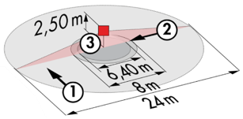
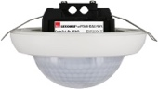
PD4N-BMS-DALI2-SM/FC: Ø 24 m across, Ø 8 m towards, Ø 6,40 m seated
Applications: Amphitheater

