LIGHTING CONTROLS

An intelligent lighting management system will be installed in the amphitheaters, ensuring that the light sources are completely switched off when not in use. The system will ensure modularity of operation depending on the activity, conference, projection, etc., and should be scalable to allow for possible extension to new facilities. The principle will be based on an Addressable DALI BUS. Commissioning and modifications will be carried out via dedicated programming software, connected locally, or via a WEB interface on the LAN or WLAN network and will be at the manufacturer's expense.

The system is either stand-alone or can be linked to GTB system by interfacing the DALI protocol to the BACnet protocol.

Through the components connected to the BUS, this solution will provide the following functions

- Occupancy management by presence detection
- Dimming of lighting, constant light threshold
- Main lighting of the amphitheater segmented into at least 2 groups: 1st day / 2nd day
- Management of lecturer lighting
- Table Management or screen lighting
- By control panel not accessible to the public:
Override Management of the different lighting circuits (On / Off / Dimming)
Lighting Scenarios Management (Conference, Projection...)
- Control of air renewal by information from presence sensors to the HVAC unit
- Re-lighting in the event of a fire

The system selected will be the DALISYS brand BEG LUXOMAT or technically equivalent comprising the following equipment:

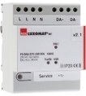
- DALI BUS power supply type PS-DALISYS-USB-REG
230V AC / 16V DC DALI BUS / 210mA / 300 m BUS max
Up to 64 participants on the BUS (DALI luminaires / Multi-sensors / PB interface…)
8 control zones per power supply / 16 groups / 16 scenes

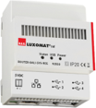
- DALI router type ROUTER-DALISYS-REG or ROUTER-DALISYS-BACnet-REG if attached to the BMS
5V DC power supply (power supply included)
LAN connection via ETHERNET
Up to 4 DALI power supplies connected via USB to one router / max. 100 routers per installation

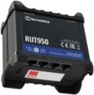
- 4G WIFI LTE Router type LTE-ROUTER-RUT950-DALISYS
Power supply from 230V AC mains sockets
Connection to the LAN network via Ethernet of DALI-SYS components and Ethernet switch
WIFI connection for the commissioning of the project by the builder
LTE connection with up 2 SIM cards for remote maintenance by the manufacturer

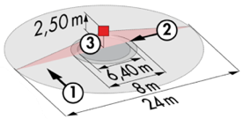
- DALI multi-sensors type PD4-DALISYS-FC
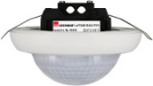
Power supply and communication via DALI BUS 16V DC
Area zone h=2.50m: Ø 24 m across, Ø8 m towards, Ø6,40 m seated
Protection class IP20/Class 2/CE
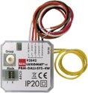
- DALI PB interface type BM-DALISYS-4W
Power supply and communication via DALI BUS 16V DC
4 independently interfaceable binary inputs
Can be combined with all manufacturers’ pushbuttons

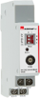
- Relay Module Interface type RM-DALISYS-1C-REG
Power supply and communication via DALI BUS 16V DC
Switching power: 3000W Cos ϕ = 1/1500VA Cos ϕ = 0.5 /300 W LED sources

