LIGHTING CONTROLS

Generally, the lighting will be controlled by presence and luminosity detectors. The type, number, brightness, and time settings of the detectors shall be adapted to the premises and the lighting sources being controlled. The circuits shall be properly subdivided so that only dark areas are lit during the day. All detectors shall be adjustable by remote control.

Operating principles and material requirements

1- Management of the entrance hall, common corridors, stairwells, airlocks, small rooms, exteriors, and car park:
Automatic operation by presence and luminosity detector

Detector type PD3N-1C for ceiling mounting (flush-mounted or surface-mounted depending on the nature of the ceiling) of the brand BEG LUXOMAT or technically equivalent and will have the following characteristics:
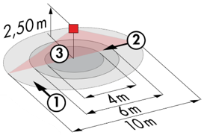
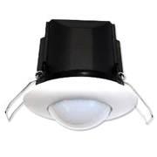
Protection class: SM: IP44, FC: IP23/Class II/CE
Detection area h=2.50 m: Ø 10 m across, Ø 6 m towards, Ø 4 m activity seat
Switching power: 2300W cos φ 1/1150VA cos φ 0.5, LED 300W max
Follow-up time: 30 s to 30 min or pulse / Brightness: 10 to 2000 Lux
Applications: Entrance Hall / Small corridors / Airlocks / Small rooms...

LC Plus 280° wall-mounted detector of the brand BEG LUXOMAT or technically equivalent and will have the following characteristics:

Degree / protection class: IP54/Class II/CE
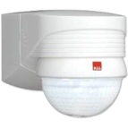
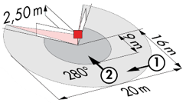
Detection area: h=2,50 m: 16 m across, 9 m towards, 2 m vertical
Switching power: 2000W cos φ 1/1000VA cos φ 0.5, LED 250W maxi
Follow-up time: 15 s to 16 min or pulse / Brightness: 2 to 2500 Lux
Applications: Stairs / Parking / Outdoors

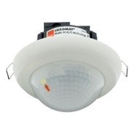
Detector type PD4N-1C-C-FC for ceiling mounting (recessed or surface mounting depending on the nature of the ceiling) of the brand BEG LUXOMAT or technically equivalent and will have the following characteristics:
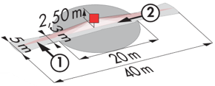
Protection class: SU: IP44, FC: IP23/Class II/CE,
Detection area h=2.50 m: 40 x 5 m across, 20 x 3 m towards, Ø8 m vertical
Switching power: 2300W cos φ 1/1150VA cos φ 0.5, LED 300W max
Follow-up time: 30 s to 30 min or pulse / Brightness: 10 to 2000 Lux
Applications: Large areas of traffic

Detector type PD4N-1C-SU for surface mounting on the ceiling of the brand BEG LUXOMAT or technically equivalent and will have the following characteristics:
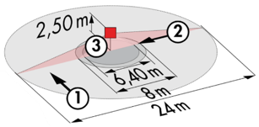
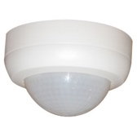
Protection class: SU: IP44
Detection area h=2.50 m: Ø 24 m across, Ø 8 m towards, Ø 6,40 m seated
Switching power: 2300W cos φ 1/1150VA cos φ 0.5, LED 300W max
Follow-up time: 30 s to 30 min or pulse / Brightness: 10 to 2000 Lux
Applications: Parking

