LIGHTING CONTROLS

Generally, lighting management will be carried out by presence and brightness detectors. The nature of the detectors, the number, the brightness, and time delay adjustment values ​​will be adapted to the premises and to the controlled lighting sources. Circuits will be properly subdivided so that only dark areas are lit during the day. All detectors must be adjustable by remote control.

Principles of operation and material requirements

1- Exteriors Management, Small Premises, Parking:
Automatic operation by presence and light detector

LC Plus 280° wall-mounted detector of the brand BEG LUXOMAT or technically equivalent and will have the following characteristics:
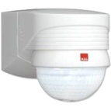
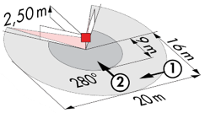
Degree / protection class: IP54/Class II/CE
Detection area: h=2,50 m: 16 m across, 9 m towards, 2 m vertical
Switching power: 2000W cos φ 1/1000VA cos φ 0.5, LED 250W maxi
Follow-up time: 15 s to 16 min or pulse / Brightness: 2 to 2500 Lux
Applications: Outdoor

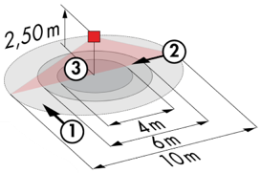
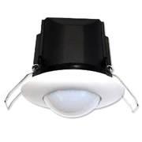
Typical detector PD3N-1C for ceiling mounting (recessed or surface-mounted depending on the nature of the ceiling) of the BEG LUXOMAT brand or technically equivalent and will have the following characteristics:

Degree / protection class: IP44, FC: IP54/Class II/CE
Detection area: h=2,50 m: Ø 10 m across, 6 m towards, 4 m seated
Switching power: 2300W cos φ 1/1150VA cos φ 0.5, LED 300W maxi
Follow-up time: 30 s to 30 min or pulse / Brightness: 10 to 2500 Lux
Applications: Toilets / Lockers rooms / Equipment rooms / Airlocks…

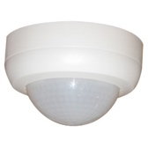
Typical detector PD4N-1C-SM for surface mounting on the ceiling of the BEG LUXOMAT brand or technically equivalent and will have the following characteristics:
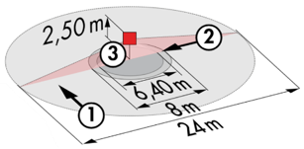
Degree / protection class: SM: IP44
Detection area: h=2,50 m: Ø 24 m across, 8 m towards, 6,40 m seated
Switching power: 2300W cos φ 1/1150VA cos φ 0.5, LED 300W maxi
Follow-up time: 30 s to 30 min or pulse / Brightness: 10 to 2000 Lux
Applications: Parking

2- Offices Management, Trays and Meeting Rooms, Circulation and Stairwells:
An intelligent lighting management system will be installed in the premises concerned, ensuring that the light sources are completely switched off when not in use. The system will ensure the modularity of the installations, making it possible to easily modify the partitions, without having to intervene in the luminaires or the wiring, and will have to be scalable, making it possible to anticipate a possible extension to new installations. The principle will be based on an addressable DALI BUS. Commissioning and modifications will be carried out via dedicated programming software, connected locally, or via a WEB interface on the LAN or WLAN network and will be at the manufacturer’s expense.

At the customer’s request, the system will allow, via a supervision, a complete control of the installations, a visualization of the lighting status and the reception of information for maintenance. The system will be autonomous or can be linked to the BMS by interfacing the DALI protocol to the BACnet protocol.

Through the components connected to the BUS, this solution will provide the following characteristics:

2.1- Offices Management, Floors Offices and Meeting Rooms
- Occupancy management by presence or absence detection / Variable lighting, constant light threshold
- User overrides by local PO or “wireless” interface
- Lighting scenarios creation and/or atmospheres in the meeting rooms for projection or video conferencing
- Air exchange control by informing the HVAC package of the presence sensors

2.2- Circulation Management and Stairwells
- Occupancy management by presence and light detection
- The lighting management system will offer the possibility to create an intelligent operation of the clearances, thus saving energy. Only the occupied zone will be switched on at the regulated value, and in anticipation, the upstream zone will be switched on at reduced power.
- In stairwells, this solution will ensure level-by-level operation.

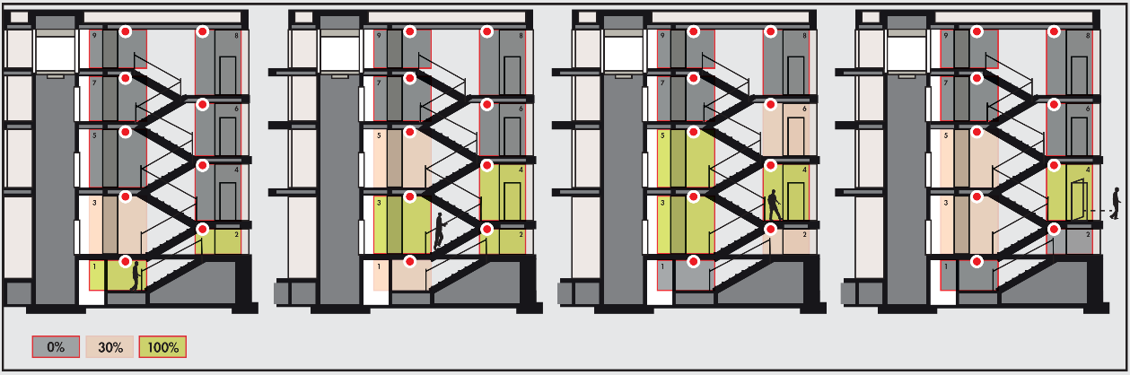
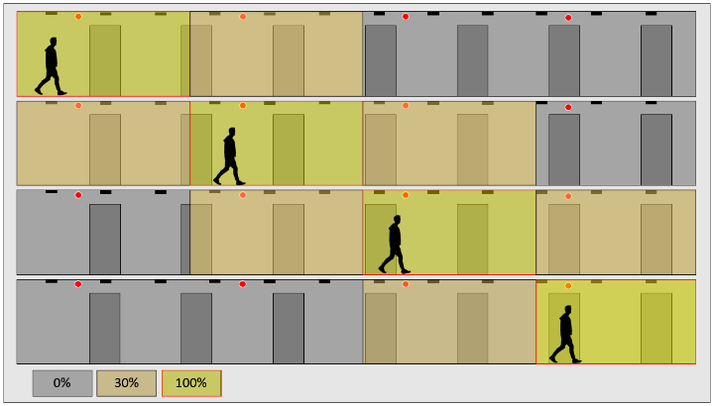

The system selected will be the DALI-SYS of the brand BEG LUXOMAT or technically equivalent, comprising the following characteristics:

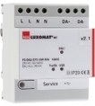
- DALI BUS power supply type PS-DALISYS-USB-REG
230V AC / 16V DC DALI BUS / 210mA / 300 m BUS max
Up to 64 participants on the BUS (DALI luminaires / Multi-sensors / PB interface…)
8 control zones per power supply / 16 groups / 16 scenes

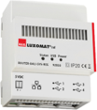
- DALI router type ROUTER-DALISYS-REG or ROUTER-DALISYS-BACnet-REG if attached to the BMS
5V DC power supply (power supply included)
LAN connection via ETHERNET
Up to 4 DALI power supplies connected via USB to one router / max. 100 routers per installation

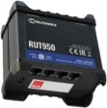
- 4G WIFI LTE Router type LTE-ROUTER-RUT950-DALISYS
Power supply from 230V AC mains sockets
Connection to the LAN network via Ethernet of DALI-SYS components and Ethernet switch
WIFI connection for the commissioning of the project by the builder
LTE connection with up 2 SIM cards for remote maintenance by the manufacturer

- Supervision type VISTATION-DALISYS-REG
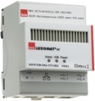
5V DC power supply (power supply included)
LAN connection via ETHERNET
Visualization on plan, customized building
Remote control of lighting / Setting of user rights

- DALI multi-sensors type PDx-DALISYS
Power supply and communication via DALI BUS 16V DC
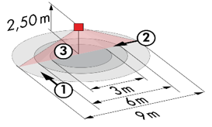
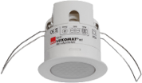
PD11-DALISYS FC: Ø 9 m across, Ø 6 m towards, Ø 3 m seated
Applications: Offices / Trailers Office
PD4N-DALISYS-C SM/FC: 40 x 5 m across, 20 x 3 m towards, Ø 8 m vertical
Applications: Circulation
PD4N-DALISYS SM/FC: Ø 24 m across, Ø 8 m towards, 6,40 m seated
Applications: Meeting rooms / Halls
LC-plus-DALISYS: 16 m across, 9 m towards, 2 m vertical
Applications: Stairs
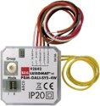
- DALI PB interface type BM-DALISYS-4W
Power supply and communication via DALI BUS 16V DC
4 independently interfaceable binary inputs
Can be combined with all manufacturers’ pushbuttons

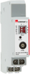
- Relay Module Interface type RM-DALISYS-1C-REG
Power supply and communication via DALI BUS 16V DC
Switching power: 3000W Cos ϕ = 1/1500VA Cos ϕ = 0.5 /300 W LED sources
