LIGHTING CONTROLS

Generally, lighting management will be carried out by presence and brightness detectors. The type, the number, the brightness, and time delay adjustment values ​​will be adapted to the premises and to the controlled lighting sources. Circuits will be properly subdivided so that only dark areas are lit during the day. All detectors must be adjustable by remote control.

Principles of operation and material requirements

1- Small Premises Management:
Automatic operation by presence and luminosity detector

Detector type PD3N-1C for ceiling mounting (flush-mounted or surface-mounted depending on the nature of the ceiling) of the brand BEG LUXOMAT or technically equivalent and will have the following characteristics:

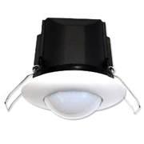
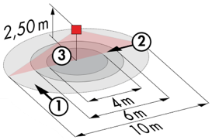
Protection class: SM: IP44, FC: IP23/Class II/CE
Detection area h=2.50 m: Ø 10 m across, Ø 6 m towards, Ø 4 m activity seat
Switching power: 2300W cos φ 1/1150VA cos φ 0.5, LED 300W max
Follow-up time: 30 s to 30 min or pulse / Brightness: 10 to 2000 Lux
Applications: Sanitary / Cloakrooms / Technical rooms / Airlocks...

2- Operating principles of the rooms:
- Bathroom management
Automatic operation by presence and luminosity detector
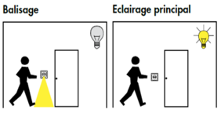
- Orientation lighting management
Automatic operation by presence and luminosity detector. The beaconing will allow the nurse carrying out his rounds or the resident to bring an orientation light in case of detection
- Entrance lighting management
Semi-automatic operation by absence and luminosity detector. A push button, integrated in the detector, will allow the entrance lighting to be switched on manually and voluntarily. Only the extinction will be automatic

Detector type PD9-M-1C-IP65-FC for flush ceiling mounting, brand BEG LUXOMAT or technically equivalent, with the following characteristics:
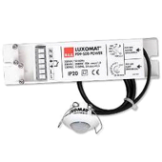
Protection class: Detection head: IP65/Class III/CE, Power supply IP20/Class II/CE
Detection area h=2.50 m: Ø 10 m across, Ø6 m towards, Ø4 m seated
Switching power: 2300W cos φ 1/1150VA cos φ 0.5, LED 300W max
Follow-up time: 15 s to 30 min or pulse / Brightness: 10 to 2000 Lux
Application: Showers

Detector type Indoor 140L for wall flush mounting, installation height 1.10 m of the brand BEG LUXOMAT or technically equivalent and will have the following characteristics:
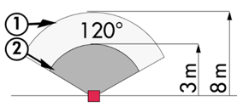
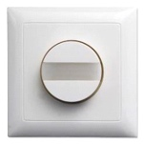
Protection class: FM: IP20/Class II/CE,
Detection zones h=1.10 m: 8 m across, 3 m towards
Switching power: 2000W cos φ 1/1000VA cos φ 0.5, LED 250W max
Follow-up time: 15 s to 30 min or pulse / Brightness: 10 to 2000 Lux
Functions: Beaconing / Night light. Integrated push button for manual control of the lighting
Application: Orientation lighting / Entrance lighting

3- Offices Management, Corridors, Stairwells and Lounges:
An intelligent lighting management system will be installed in the premises concerned, ensuring that the light sources are completely switched off when not in use. The system will ensure the modularity of the installations, making it possible to easily modify the partitions, without having to intervene in the luminaires or the wiring, and will have to be scalable, making it possible to anticipate a possible extension to new installations. The principle will be based on an addressable DALI BUS. Commissioning and modifications will be carried out via dedicated programming software, connected locally, or via a WEB interface on the LAN or WLAN network and will be at the manufacturer’s expense.

At the customer’s request, the system will allow, via a supervision, a complete control of the installations, a visualization of the lighting status and the reception of information for maintenance. The system will be autonomous or can be linked to the BMS by interfacing the DALI protocol to the BACnet protocol.

Through the components connected to the BUS, this solution will provide the following functions:

3.1- Office management
- Occupancy management by absence detection / Lighting variation, constant lighting threshold
- User" overrides by local PB
- Control of air renewal by information from presence sensors to the HVAC unit

3.2- Circulation management
- Occupancy management by presence and luminosity detection
- Daytime operation: By time circuit, during the hours of public occupation in the building, in case of unoccupation, the lighting of the corridors will be switched on at the minimum regulatory value. By presence detection, switching on at the set value. The lighting management system will also offer the possibility to create an intelligent operation of the corridors, thus saving energy. Only the occupied zone and the upstream zone will be switched on at the regulatory value, the other zones will remain at reduced power (10 / 20%)
- Night operation: By time circuit, outside the hours of public occupation in the building, the lighting of the corridors will be lowered to the minimum regulatory value, thus avoiding too much light entering the residents' rooms during the nurses' rounds
- In the stairwells, this solution will ensure level by level operation
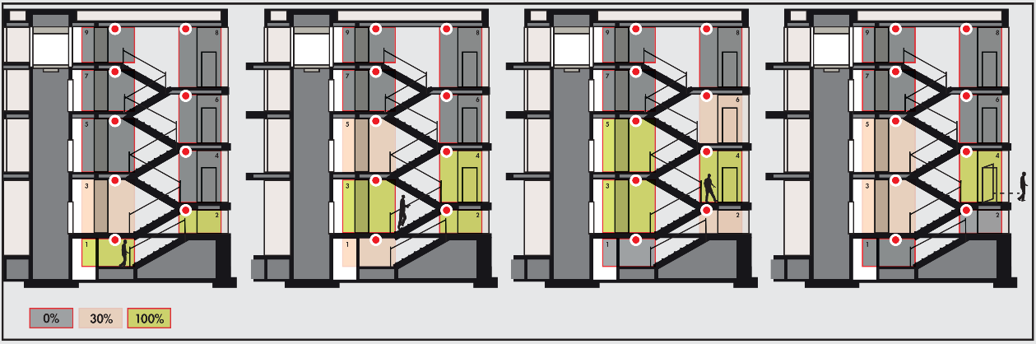
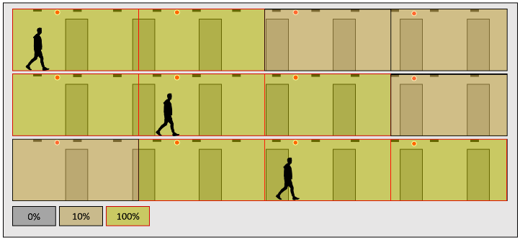

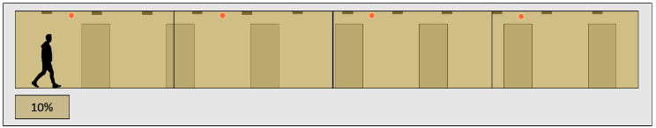

3.3- Lounge management
- Occupancy management by absence detection / Lighting variation, constant lighting threshold
- Lighting segmented into at least 2 groups: Window side management, corridor side management
- User" overrides by local PB
- Creation of environment scenarios according to the activity carried out
- Control of air renewal by information from presence sensors to the HVAC unit

The system selected will be the DALI-SYS of the brand BEG LUXOMAT or technically equivalent, comprising the following characteristics:

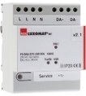
- DALI BUS power supply type PS-DALISYS-USB-REG
230V AC / 16V DC DALI BUS / 210mA / 300 m BUS max
Up to 64 participants on the BUS (DALI luminaires / Multi-sensors / PB interface…)
8 control zones per power supply / 16 groups / 16 scenes

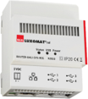
- DALI router type ROUTER-DALISYS-REG or ROUTER-DALISYS-BACnet-REG if attached to the BMS
5V DC power supply (power supply included)
LAN connection via ETHERNET
Up to 4 DALI power supplies connected via USB to one router / max. 100 routers per installation

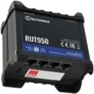
- 4G WIFI LTE Router type LTE-ROUTER-RUT950-DALISYS
Power supply from 230V AC mains sockets
Connection to the LAN network via Ethernet of DALI-SYS components and Ethernet switch
WIFI connection for the commissioning of the project by the builder
LTE connection with up 2 SIM cards for remote maintenance by the manufacturer

- Supervision type VISTATION-DALISYS-REG
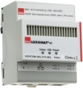
5V DC power supply (power supply included)
LAN connection via ETHERNET
Visualization on plan, customized building
Remote control of lighting / Setting of user rights

- DALI multi-sensors type PDx-DALISYS
Power supply and communication via DALI BUS 16V DC
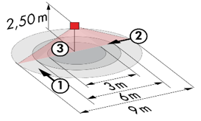
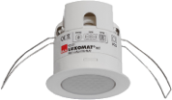
PD4N-DALISYS-C SM/FC: 40 x 5 m across, 20 x 3 m towards, Ø 8 m vertical
Applications: Circulation
PD4N-DALISYS SM/FC: Ø 24 m across, Ø 8 m towards, 6,40 m seated
Applications: Meeting rooms / Halls
LC-plus-DALISYS: 16 m across, 9 m towards, 2 m vertical
Applications: Stairs
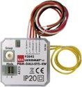
- DALI PB interface type BM-DALISYS-4W
Power supply and communication via DALI BUS 16V DC
4 independently interfaceable binary inputs
Can be combined with all manufacturers’ pushbuttons

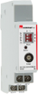
- Relay Module Interface type RM-DALISYS-1C-REG
Power supply and communication via DALI BUS 16V DC
Switching power: 3000W Cos ϕ = 1/1500VA Cos ϕ = 0.5 /300 W LED sources

