LIGHTING CONTROLS

Generally, lighting management will be carried out by presence and brightness detectors. The type, the number, the brightness, and time delay adjustment values ​​will be adapted to the premises and to the controlled lighting sources. Circuits will be properly subdivided so that only dark areas are lit during the day. All detectors must be adjustable by remote control.

Principles of operation and material requirements

1- Traffic, Stairwells, Exteriors, Small Premises, Parking Management:
Automatic operation by presence and light detector

LC Plus 280° wall-mounted detector of the brand BEG LUXOMAT or technically equivalent and will have the following characteristics:
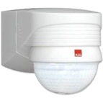
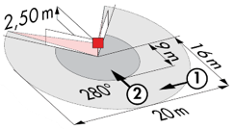
Degree / protection class: IP54/Class II/CE
Detection area: h=2,50 m: 16 m across, 9 m towards, 2 m vertical
Switching power: 2000W cos φ 1/1000VA cos φ 0.5, LED 250W maxi
Follow-up time: 15 s to 16 min or pulse / Brightness: 2 to 2500 Lux
Applications: Outdoor

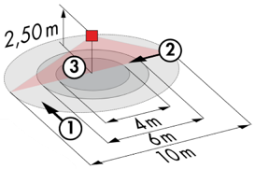
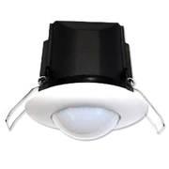
Typical detector PD3N-1C for ceiling mounting (recessed or surface-mounted depending on the nature of the ceiling) of the BEG LUXOMAT brand or technically equivalent and will have the following characteristics:

Degree / protection class: IP44, FC: IP54/Class II/CE
Detection area: h=2,50 m: Ø 10 m across, 6 m towards, 4 m activity seat
Switching power: 2300W cos φ 1/1150VA cos φ 0.5, LED 300W maxi
Follow-up time: 30 s to 30 min or pulse / Brightness: 10 to 2500 Lux
Applications: Toilets / Lockers rooms / Equipment rooms / Airlocks…

Typical detector PD4-M-1C + Slaves in ceiling mounting (recessed or surface-mounted depending on the nature of the ceiling) of the BEG LUXOMAT brand or technically equivalent and will have the following characteristics:

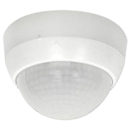
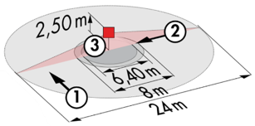
Degree / protection class: IP54 with base/Class II/CE
Detection area: h=2,50 m: Ø 24 m across, Ø 8 m towards, 6,40 m seat activity
Switching power: 2300W cos φ 1/1150VA cos φ 0.5, LED 300W maxi
Follow-up time: 30 s to 30 min or pulse / Brightness: 10 to 2000 Lux
Applications: Porch

2- Management of offices, teaching rooms, study rooms, refectory, corridors, and stairwells:
The lighting management will be based on DALI2 technology, according to IEC 62386 standard. The DALI bus will be used to connect luminaires and presence detectors via controllers or bus interfaces connected to the BMS. The management system will automatically dim the lighting to take account of natural light and allow the light sources to be switched off completely when unoccupied. This solution will offer the possibility of modulating the functions according to the specificities of each room and will have to be scalable to anticipate a possible extension to new installations. Each luminaire will be addressed individually, to report the status and faults of each device to the supervision system.

Through the components connected to the BUS, this solution will provide the following functions

2.1- Management of Offices, Infirmary, Teachers' Room
- Occupancy management by absence detection / Lighting variation, constant lighting threshold
- User" overrides by local BP
- Control of air renewal and temperature by information from presence sensors to the HVAC unit
- GTB link

2.2- Management of teaching rooms, study rooms
- Occupancy management by absence detection / Lighting variation, constant lighting threshold
- Lighting segmented into at least 3 groups: Window side, corridor side and blackboard side management
- User" overrides per local PB, at least 1 for the Classroom, 1 for the Blackboard
- Creation of a projection scenario: Switching off the blackboard lighting, lowering the room lighting to 10%.
- Control of air exchange and temperature by informing the HVAC package of presence sensors
- GTB link

2.3- Refectory management
- Occupancy management by presence detection / Lighting variation, constant lighting threshold
- Lighting segmented into at least 2 groups: Window side management, corridor side management
- Users" derogations by local BP, not accessible to the public
- Control of air exchange and temperature by information from presence sensors to the HVAC unit
- GTB link

2.4- Management of Circulation, Halls and Stairwells
- Management of occupancy by presence and luminosity detection
- Lowering to the minimum regulatory threshold in case of unoccupation
- In the stairwells, this solution will ensure level by level operation
- GTB link

The selected sensors will be " Multi-Master " on DALI 2 protocol of BEG LUXOMAT brand or technically equivalent and will have the following technical characteristics:

- Multi-sensor DALI type PDx-BMS-DALI2
DALI Multi-Master technology according to IEC 62386, part 103
Compatible with DALI 2 controllers according to IEC 62386 part 101/103/304. Section 0 provides information on room assignment and motion detection on the DALI bus according to IEC 62386 part 303. Section 1 provides the LUX values on the DALI bus according to IEC 62386 part 304. Parameterization is possible via a multi-master application controller from any manufacturer on DALI 2 protocol.
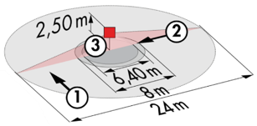
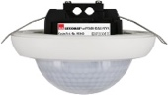
PD4N-BMS-DALI2-SM/FC: Ø 24 m across, Ø 8 m towards, Ø 6,40 m seat activity
Applications: Offices / Halls / Teaching and study rooms / Refectory
PD4N-BMS-DALI2-C SM/FC: 40 x 5 m across, 20 x 3 m towards, Ø 8 m vertical
Applications: Circulation
LC-Mini-120°-BMS-DALI2: 12 m across, 3 m towards
Applications: Stairs
