LIGHTING CONTROLS

Generally, lighting management will be carried out by presence and brightness detectors. The type, the number, the brightness, and time delay adjustment values ​​will be adapted to the premises and to the controlled lighting sources. Circuits will be properly subdivided so that only dark areas are lit during the day. All detectors must be adjustable by remote control.

Principles of operation and material requirements

1- Small premises Management:
Automatic operation by presence and luminosity detector

Detector type PD3N-1C for ceiling mounting (flush-mounted or surface-mounted depending on the nature of the ceiling) of the brand BEG LUXOMAT or technically equivalent and will have the following characteristics:

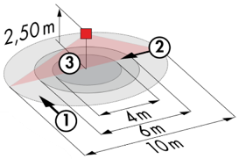
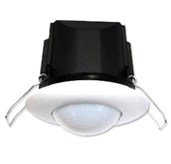
Protection class: SM: IP44, FC: IP23/Class II/CE
Detection area h=2.50 m: Ø 10 m across, Ø 6 m towards, Ø 4 m activity seat
Switching power: 2300W cos φ 1/1150VA cos φ 0.5, LED 300W max
Follow-up time: 30 s to 30 min or pulse / Brightness: 10 to 2000 Lux
Applications: Sanitary / Cloakrooms / Technical rooms / Airlocks...

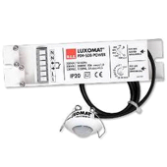
Detector type PD9-M-1C-IP65-FT for flush ceiling mounting, brand BEG LUXOMAT or technically equivalent, with the following characteristics

Protection class: Detection head: IP65/Class III/CE, Power supply IP20/Class II/CE
Detection area h=2.50 m: Ø 10 m across, Ø 6 m towards, Ø 4 m seated
Switching power: 2300W cos φ 1/1150VA cos φ 0.5, LED 300W max
Follow-up time: 15 s to 30 min or pulse / Brightness: 10 to 2000 Lux
Application: Showers

2- Management of the Gymnasium, Sports Halls, Circulation and Stairwells:
The lighting management will be based on DALI2 technology, according to IEC 62386 standard. The DALI bus will be used to connect luminaires and presence detectors via controllers or bus interfaces connected to the GTB. The management system will automatically dim the lighting to take account of natural light and allow the light sources to be switched off completely when unoccupied. This solution will offer the possibility of modulating the functions according to the specificities of each room and will have to be scalable to anticipate a possible extension to new installations. Each luminaire will be addressed individually, to report the status and faults of each device to the supervision system.

Through the components connected to the BUS, this solution will provide the following functions:

2.1- Management of Circulation, Halls and Stairwells
- Occupancy management by presence and luminosity detection
- Lowering to the minimum regulatory threshold in case of unoccupation
- In the stairwells, this solution will ensure level by level operation
- GTB Link

2.2- Gymnasium and sports hall management
- Occupancy management by absence detection - Lighting by control panel, not accessible to the public
- Lighting variation, constant lighting threshold for training thresholds only
- Fixed thresholds, without lighting regulation for competition
- Modularity according to the activities practiced, ½ court or full court, management of a climbing wall...
- Control of air renewal by information from the presence sensors to the HVAC package
- GTB link

The sensor selected will be a "multi-Master" type on DALI 2 protocol from BEG LUXOMAT or technically equivalent and will have the following technical characteristics

- DALI multi-sensor type PDx-BMS-DALI2
DALI Multi-Master technology according to IEC 62386, part 103
Compatible with DALI 2 controllers according to IEC 62386 part 101/103/303/304. Section 0 provides information on room assignment and motion detection on the DALI bus according to IEC 62386 part 303. Section 1 provides LUX values on the DALI bus according to IEC 62386 part 304. Parameterization is possible via a multi-master application controller from any manufacturer on DALI 2 protocol.

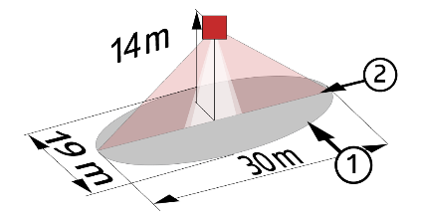
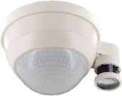
PD4N-BMS-DALI2-SM/FC: Ø 24 m across, Ø 8 m towards, Ø 6,40 m seated
Applications: Halls
PD4N-BMS-DALI2-C SM/FC: 40 x 5 m across, 20 x 3 m towards, Ø 8 m vertical
Applications: Circulation
LC-Mini-120°-BMS-DALI2: 12 m across, 3 m towards
Applications: Stairs
PD4-BMS-DALI2-Large Height: Ø 30 x Ø 19 m towards
Applications: Gymnasium / Sports Halls

