LIGHTING CONTROLS

Generally, lighting management will be carried out by presence and brightness detectors. The type, the number, the brightness, and time delay adjustment values ​​will be adapted to the premises and to the controlled lighting sources. Circuits will be properly subdivided so that only dark areas are lit during the day. All detectors must be adjustable by remote control.

Principles of operation and material requirements

1- Small premises Management:
Automatic operation by presence and luminosity detector

Detector type PD3N-1C for ceiling mounting (flush-mounted or surface-mounted depending on the nature of the ceiling) of the brand BEG LUXOMAT or technically equivalent and will have the following characteristics:

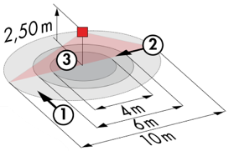
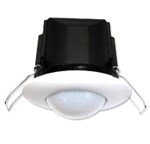
Protection class: SM: IP44, FC: IP23/Class II/CE
Detection area h=2.50 m: Ø 10 m across, Ø 6 m towards, Ø 4 m activity seat
Switching power: 2300W cos φ 1/1150VA cos φ 0.5, LED 300W max
Follow-up time: 30 s to 30 min or pulse / Brightness: 10 to 2000 Lux
Applications: Sanitary / Cloakrooms / Technical rooms / Airlocks...

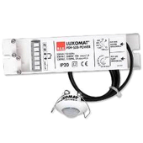
Detector type PD9-M-1C-IP65-FT for flush ceiling mounting, brand BEG LUXOMAT or technically equivalent, with the following characteristics

Protection class: Detection head: IP65/Class III/CE, Power supply IP20/Class II/CE
Detection area h=2.50 m: Ø 10 m across, Ø 6 m towards, Ø 4 m seated
Switching power: 2300W cos φ 1/1150VA cos φ 0.5, LED 300W max
Follow-up time: 15 s to 30 min or pulse / Brightness: 10 to 2000 Lux
Application: Showers

2- Management of the Gymnasium, Sports Halls, Circulation and Stairwells:
An intelligent lighting management system will be installed in the amphitheaters, ensuring that the light sources are completely switched off when not in use. The system will ensure modularity of operation depending on the activity, conference, projection, etc., and should be scalable to allow for possible extension to new facilities. The principle will be based on an Addressable DALI BUS. Commissioning and modifications will be carried out via dedicated programming software, connected locally, or via a WEB interface on the LAN or WLAN network and will be at the manufacturer's expense.

The system is either stand-alone or can be linked to GTB system by interfacing the DALI protocol to the BACnet protocol.

Through the components connected to the BUS, this solution will provide the following functions:

2.1- Management of Circulation, Halls and Stairwells
- Occupancy management by presence and lighting detection
- The lighting management system will offer the possibility to create an intelligent operation of the corridors, thus allowing energy savings. Only the occupied area will be switched on at the required value, and in anticipation, the upstream area will be switched on at reduced power
- In stairwells, this solution will ensure level by level operation
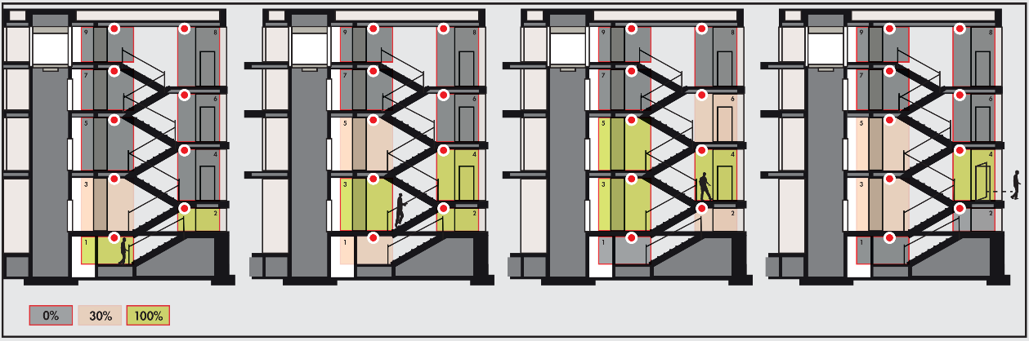
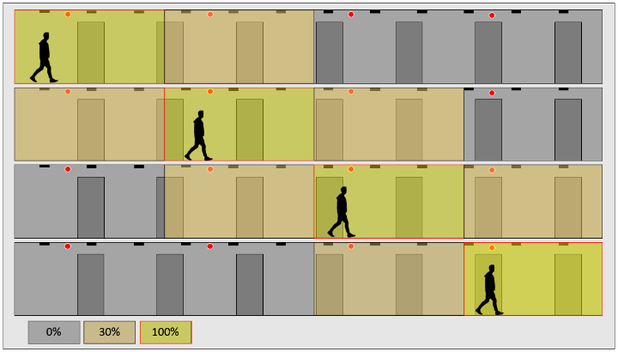

2.2- Gymnasium and Sports Hall Management
- Occupancy management by absence detection - Lighting by control panel, not accessible to the public
- Lighting variation, constant lighting threshold for training thresholds only
- Fixed thresholds, without lighting regulation for competition
- Modularity according to the activities practiced, ½ court or full court, management of a climbing wall...
- Control of air renewal by information from the presence sensors to the HVAC package

The system selected will be the DALISYS brand BEG LUXOMAT or technically equivalent comprising the following equipment:

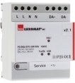
- DALI BUS power supply type PS-DALISYS-USB-REG
230V AC / 16V DC DALI BUS / 210mA / 300 m BUS max
Up to 64 participants on the BUS (DALI luminaires / Multi-sensors / PB interface…)
8 control zones per power supply / 16 groups / 16 scenes

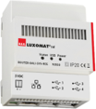
- DALI router type ROUTER-DALISYS-REG or ROUTER-DALISYS-BACnet-REG if attached to the BMS
5V DC power supply (power supply included)
LAN connection via ETHERNET
Up to 4 DALI power supplies connected via USB to one router / max. 100 routers per installation

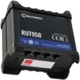
- 4G WIFI LTE Router type LTE-ROUTER-RUT950-DALISYS
Power supply from 230V AC mains sockets
Connection to the LAN network via Ethernet of DALI-SYS components and Ethernet switch
WIFI connection for the commissioning of the project by the builder
LTE connection with up 2 SIM cards for remote maintenance by the manufacturer

- DALI multi-sensors type PDx-DALISYS
Power supply and communication via DALI BUS 16V DC

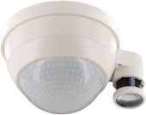
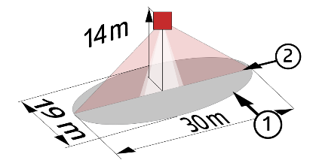
PD4N-DALISYS-C SM/FC/FM: 40 x 5 m across, 20 x 3 m towards, Ø 8 m vertical
Applications: Circulation
PD4N-DALISYS SM/FC/FM: Ø 24 m across, Ø 8 m towards, Ø6,40 m seated
Applications: Sports halls / Halls
LC-PLUS-DALISYS: 16 m across, 9 m towards, 2 m vertical
Applications: Stairs
PD4-DALISYS-GH-SM: Ø 30 x Ø19 m towards
- Applications: Gymnasium
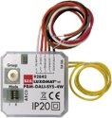
- DALI PB interface type BM-DALISYS-4W
Power supply and communication via DALI BUS 16V DC
4 independently interfaceable binary inputs
Can be combined with all manufacturers’ pushbuttons

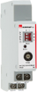
- Relay Module Interface type RM-DALISYS-1C-REG
Power supply and communication via DALI BUS 16V DC
Switching power: 3000W Cos ϕ = 1/1500VA Cos ϕ = 0.5 /300 W LED sources

