LIGHTING CONTROLS

Generally, lighting management will be carried out by presence and brightness detectors. The type, the number, the brightness, and time delay adjustment values ​​will be adapted to the premises and to the controlled lighting sources. Circuits will be properly subdivided so that only dark areas are lit during the day. All detectors must be adjustable by remote control.

Principles of operation and material requirements

1- Circulation, Halls, Stairwells Management:
Automatic operation by presence and luminosity detector on 2/3 of the lighting, 1/3 on a control system not accessible to the public allowing compliance with EC6.1 regulations

Typical detector PD4-M-1C-Corridor + Slaves in ceiling mounting (recessed or surface-mounted depending on the nature of the ceiling) of the BEG LUXOMAT brand or technically equivalent and will have the following characteristics:
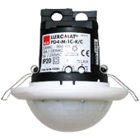
Degree / protection class: SM: IP54 with base, FC: IP20/Class II/CE
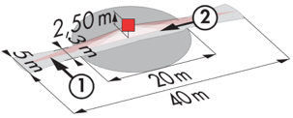
Detection area: h=2,50 m: 40 x 5 m across, 20 x 3 m towards, Ø 8 m vertical
Switching power: 2300W cos φ 1/1150VA cos φ 0.5, LED 300W maxi
Follow-up time: 30 s to 30 min or pulse / Brightness: 10 to 2000 Lux
Permanent control of daylight and artificial light
Applications: Circulations

Typical detector PD4-M-1C + Slaves in ceiling mounting (recessed or surface-mounted depending on the nature of the ceiling) of the BEG LUXOMAT brand or technically equivalent and will have the following characteristics:
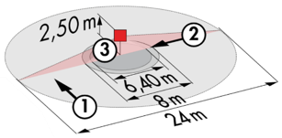
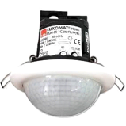
Degree / protection class: SM: IP54 with base, FC: IP20/Class II/CE
Detection area: h=2,50 m: Ø 24 m across, Ø 8 m towards, Ø 6,40 m activity seat
Switching power: 2300W cos φ 1/1150VA cos φ 0.5, LED 300W maxi
Follow-up time: 30 s to 30 min or pulse / Brightness: 10 to 2000 Lux
Permanent control of daylight and artificial light
Applications: Halls / Porches

LC Plus 280° wall-mounted detector of the brand BEG LUXOMAT or technically equivalent and will have the following characteristics:

Degree / protection class: IP54/Class II/CE
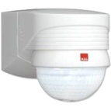
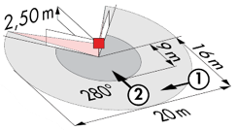
Detection area: h=2,50 m: 16 m across, 9 m towards, 2 m vertical
Switching power: 2000W cos φ 1/1000VA cos φ 0.5, LED 250W maxi
Follow-up time: 15 s to 16 min or pulse / Brightness: 2 to 2500 Lux
Applications: Stair / Outdoor

2- Small rooms Management:
Automatic operation by presence and luminosity detector

Detector type PD3N-1C for ceiling mounting (flush-mounted or surface-mounted depending on the nature of the ceiling) of the brand BEG LUXOMAT or technically equivalent and will have the following characteristics:

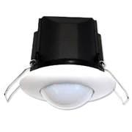
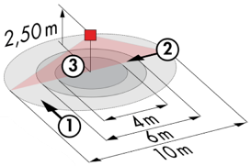
Protection class: SM: IP44, FC: IP23/Class II/CE
Detection area h=2.50 m: Ø 10 m across, Ø 6 m towards, Ø 4 m activity seat
Switching power: 2300W cos φ 1/1150VA cos φ 0.5, LED 300W max
Follow-up time: 30 s to 30 min or pulse / Brightness: 10 to 2000 Lux
Applications: Sanitary facilities / Cloakrooms / Technical rooms / Airlocks...

3- Office Management:
Semi-automatic operation by absence detector on DALI dimmable luminaires. The lighting will be switched on manually and voluntarily by pressing a button. Only dimming, considering natural light, and switching off will be automatic. The PB will also allow the user to manually control the lighting, enabling him to temporarily force the lighting to be switched on, off and dimmed.

Detector type PD4N-M-DACO-DALI 2 + Slaves for ceiling mounting (recessed or surface mounting depending on the nature of the ceiling) of the brand BEG LUXOMAT or technically equivalent and will have the following characteristics:

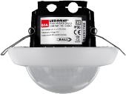
Protection class: SM: IP54 with surface-mounted accessory, FC: IP20/Class II/CE
Detection area h=2.50 m: Ø 24 m across, Ø8 m towards, Ø6,40 m seated
Interface: DALI 2 certified, digital driver control in broadcast mode
Follow-up time: 1 to 150 min or pulse / Brightness: 10 to 2500 Lux
Daylight-dependent constant dimming / 40 digital DALI drivers
Settings: Via bi-directional BEG-One smartphone application (read/write)
Applications: Offices / Infirmary / Teacher's room...

4- Teaching Rooms, Study Rooms Management:
Semi-automatic operation by absence detector on DALI dimmable luminaires. The lighting located near the windows will be controlled independently of the lighting on the corridor side, to take account of natural light. The lighting will be switched on manually and voluntarily by pressing the push button. Only the dimming, considering natural light, and the switching off will be automatic. The lighting in the panel will also be connected to the lighting management system in semi-automatic operation by absence detector on "On/Off" luminaires. The classroom and blackboard lighting control panels will also allow the user to manually control the lighting, thus allowing the lighting to be temporarily forced.

5- Refectory Management:
Automatic operation by presence detector on DALI dimmable luminaires. The lighting near the windows will be controlled independently of the lighting on the corridor side, to take account of natural light. A control panel, located near the staff entrance and not accessible to the public, will also allow staff to manually control the lighting, allowing them to temporarily force the status of the luminaires.

Detector type PD4-M-DAA4G + Slaves for ceiling mounting (recessed or surface mounting depending on the nature of the ceiling) of the brand BEG LUXOMAT or technically equivalent and will have the following characteristics:

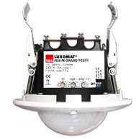
Protection class: SM: IP54 with base, FC: IP20/Class II/CE,
Detection area h=2.50 m: Ø 24 m across, Ø 8 m towards, Ø6,40 m seated
DALI: 1 DALI output segmented into up to 4 groups
Presence detector with integrated: Power supply and DALI BUS controller
Distribution:
A- One DALI zone divisible into 3 groups with constant offset control (Groups 1 to 3)
B- One DALI zone only on presence (Group 4)
C- A dry contact relay N.O. on presence (type T.O.R. panel, drivers’ extinction in standby mode, C.V.C., ...)
Switching power: 3000W cos φ 1/1500VA cos φ 0.5, LED 300W max
Follow-up time: 5 to 120 min or pulse / Brightness: 10 to 2000 Lux
Constant dimming according to daylight / 64 digital DALI drivers
Applications: Teaching rooms / Study rooms / Refectory...

