LIGHTING CONTROLS

Intelligent lighting management will be installed in the amphitheaters concerned, ensuring that the sources are completely switched off when unoccupied. The system will ensure modularity of operation according to the activity carried out, conference, projection, etc., by means of lighting scenarios controlled locally by "push button" type controls and must be scalable to allow for possible extension to new installations. The principle will be based on an addressable DALI BUS. Commissioning and modifications will be carried out via a dedicated Smartphone application in BLE (Bluetooth) communication with the system. It will be the responsibility of the contractor or the manufacturer's commissioning service.

Through the components connected to the BUS, this solution will provide the following functions:

- Occupancy management by presence detection
- Variation of lighting, constant lighting threshold
- Main lighting of the amphitheater segmented into at least 2 groups: 1st day / 2nd day
- Management of lecturer lighting
- Management of table or screen lighting
- By control panel not accessible to the public:
Override Management of the different lighting circuits (On / Off / Dimming)
Lighting scenarios Management (Conference, Projection...)
- Re-lighting in the event of a fire

The chosen system will be the DALILINK of the brand BEG LUXOMAT or technically equivalent, comprising the following equipment

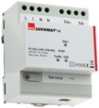
- DALI BUS power supply type PS-DALILINK-USB-REG-210mA
230V AC / 16V DC DALI BUS / 210mA / 300m BUS max
Up to 45 DALI luminaires and 10 control devices (multi-sensor / PB interface, etc.)
Max. 8 control zones per supply / 16 groups / 16 scenes

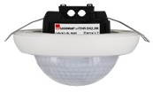
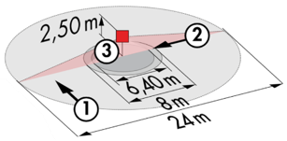
- DALI multi-sensor type PD4N-DALILINK-FC
Power supply and communication via DALI BUS 16V DC
Detection area h=2.50m: Ø 24 m across, Ø8 m towards, Ø6.4 m seated
Protection class: IP20/Class 2/CE

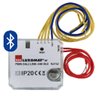
- PB DALI interface type PBM-DALILINK-4W-BLE
Power supply and communication via DALI BUS 16V DC
Bluetooth communication for parameterization
4 binary inputs can be interfaced independently
Can be combined with pushbuttons from all manufacturers
Version without Bluetooth: PBM-DALILINK-4W
