LIGHTING CONTROLS

Generally, lighting management will be carried out by presence and brightness detectors. The nature of the detectors, the number, the brightness, and time delay adjustment values ​​will be adapted to the premises and to the controlled lighting sources. Circuits will be properly subdivided so that only dark areas are lit during the day. All detectors must be adjustable by remote control.

Principles of operation and material requirements

Small Premises Management
Automatic operation by presence and light sensor

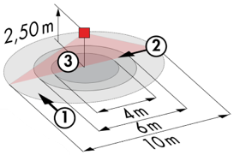
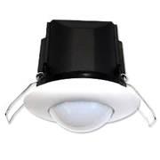
Typical detector PD3N-1C for ceiling mounting (recessed or surface-mounted depending on the nature of the ceiling) of the BEG LUXOMAT brand or technically equivalent and will have the following characteristics:

Degree / protection class: IP44, FC: IP54/Class II/CE
Detection area: h=2,50 m: Ø 10 m across, 6 m towards, 4 m activity seat
Switching power: 2300W cos φ 1/1150VA cos φ 0.5, LED 300W maxi
Follow-up time: 30 s to 30 min or pulse / Brightness: 10 to 2500 Lux
Applications: Sanitary / Changing rooms / Technical rooms...

2- Car Park Management, Circulation and Stairwells:

The lighting management will be based on DALI2 technology, according to IEC 62386 standard. The DALI bus will be used to connect luminaires and presence detectors via controllers or bus interfaces connected to the BMS. The management system will automatically dim the lighting to consider the natural light inflow and will allow the light sources to be completely switched off when unoccupied. This solution will offer the possibility of easily modifying the partitions, without intervention on the luminaires or the wiring, and will have to be evolutionary allowing to anticipate a possible extension to new installations. Each luminaire will be addressed individually, to report the status and defects of each device to the supervision system.

2.1- Parking Management
- Management of occupancy by presence and luminosity detection
- Minimum dimming of lights in case of unoccupation
- Switching on at the regulatory threshold by detecting the presence of a vehicle or person
- Lighting groups will be set up to control a maximum surface area of 500m².
- BMS link

2.2- Management of Corridors, Stairwells and Lift Landings
- Occupancy management by presence and luminosity detection
- Lowering to the minimum regulatory threshold in case of unoccupation
- Triggering at the regulatory threshold by presence detection
- In the stairwells, the system will operate level by level.
- BMS link

The selected sensors will be " Multi-Master " on DALI 2 protocol of BEG LUXOMAT brand or technically equivalent and will have the following technical characteristics:

- Multi-sensor DALI type PDx-BMS-DALI2
DALI Multi-Master technology according to IEC 62386, part 103
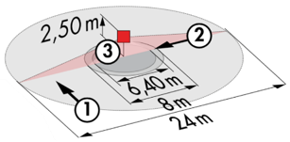
Compatible with DALI 2 controllers according to IEC 62386 part 101/103/304. Section 0 provides information on room assignment and motion detection on the DALI bus according to IEC 62386 part 303. Section 1 provides the LUX values on the DALI bus according to IEC 62386 part 304. Parameterization is possible via a multi-master application controller from any manufacturer on DALI 2 protocol.
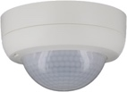
PD4N-BMS-DALI2-SM/FC: Ø 24 m across, Ø 8 m towards, Ø 6,40 m seated
Applications: Halls / Parking
PD4N-BMS-DALI2-C SM/FC: 40 x 5 m across, 20 x 3 m towards, Ø 8 m vertical
Applications: Circulation
LC-Mini-120°-BMS-DALI2: 12 m across, 3 m towards
Applications: Stairs / Sass

