LIGHTING CONTROLS

Generally, lighting management will be carried out by presence and brightness detectors. The nature of the detectors, the number, the brightness, and time delay adjustment values ​​will be adapted to the premises and to the controlled lighting sources. Circuits will be properly subdivided so that only dark areas are lit during the day. All detectors must be adjustable by remote control.

Principles of operation and material requirements

1- Small Rooms Management:
Automatic operation by presence and light sensor

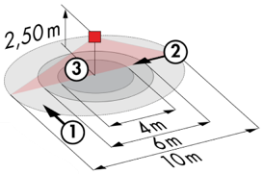
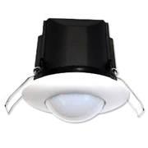
Typical detector PD3N-1C for ceiling mounting (recessed or surface-mounted depending on the nature of the ceiling) of the BEG LUXOMAT brand or technically equivalent and will have the following characteristics:

Degree / protection class: IP44, FC: IP54/Class II/CE
Detection area: h=2,50 m: Ø 10 m across, 6 m towards, 4 m activity seat
Switching power: 2300W cos φ 1/1150VA cos φ 0.5, LED 300W maxi
Follow-up time: 30 s to 30 min or pulse / Brightness: 10 to 2500 Lux
Applications: Toilets / Lockers rooms / Equipment rooms / Airlocks…

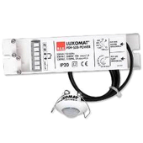
Detector type PD9-M-1C-IP65-FC for flush ceiling mounting, brand BEG LUXOMAT or technically equivalent, with the following characteristics

Protection class: Detection head: IP65/Class III/CE, Power supply IP20/Class II/CE
Detection area h=2.50 m: Ø 10 m across, Ø6 m towards, Ø4 m seated
Switching power: 2300W cos φ 1/1150VA cos φ 0.5, LED 300W max
Follow-up time: 15 s to 30 min or pulse / Brightness: 10 to 2000 Lux
Application: Showers

2- Management of the administrative building and storages:
The lighting management will be based on DALI2 technology, according to IEC 62386 standard. The DALI bus will be used to connect luminaires and presence detectors via controllers or bus interfaces connected to the BMS. The management system will automatically dim the lighting to consider the natural light inflow and will allow the light sources to be completely switched off when unoccupied. This solution will offer the possibility of easily modifying the partitions, without intervention on the luminaires or the wiring, and will have to be evolutionary allowing to anticipate a possible extension to new installations. Each luminaire will be addressed individually, to report the status and defects of each device to the supervision system.

Through the components connected to the BUS, this solution will provide the following characteristics:

2.1- Management of Offices and Meeting Rooms
- Occupancy management by presence or absence detection / Lighting variation, constant lighting threshold
- User" overrides by local PB or by "wireless" interface
- Creation of lighting scenarios and/or atmospheres in the meeting rooms for projection or videoconferencing
- Control of air renewal by information from presence sensors to the HVAC package

2.2- Management of Circulation and Stairwells
- Occupancy management by presence and luminosity detection
- The lighting management system will offer the possibility of creating an intelligent operation of the corridors, thus allowing energy savings. Only the occupied zone will be switched on at the regulatory value, and in anticipation, the upstream zone will be switched on at reduced power (10 / 20%)
- In the stairwells, this solution will ensure level by level operation

2.3- Dock management
- Occupancy management by presence and luminosity detection
- Lowering to 10% of the set point if the platform is unoccupied for a predefined time or permanently during operating hours

2.4- Management of loading zones, storage aisles and rack access routes
- Occupancy management by presence detection High Bay
- The lighting management system will offer the possibility of creating an intelligent operation of the access aisles to the racks and in the racks, thus allowing energy savings. Only the occupied zone will be switched on at the regulatory value, and in anticipation, the upstream zone will be switched on at reduced power (10 / 20%). In the event of prolonged activity in a rack, the traffic light will remain switched on to indicate the presence of a person in the rack.

The selected sensors will be " Multi-Master " on DALI 2 protocol of BEG LUXOMAT brand or technically equivalent and will have the following technical characteristics:

- Multi-sensor DALI type PDx-BMS-DALI2
DALI Multi-Master technology according to IEC 62386, part 103
Compatible with DALI 2 controllers according to IEC 62386 part 101/103/304. Section 0 provides information on room assignment and motion detection on the DALI bus according to IEC 62386 part 303. Section 1 provides the LUX values on the DALI bus according to IEC 62386 part 304. Parameterization is possible via a multi-master application controller from any manufacturer on DALI 2 protocol.

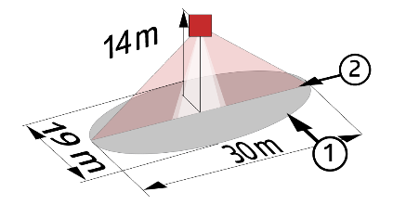
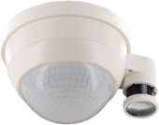
PD11-BMS-DALI2-FC: Ø 9 m across, Ø 6 m towards, Ø 3 m seated
Applications: Offices
PD4N-BMS-DALI2-SM/FC: Ø 24 m across, Ø 8 m towards, Ø 6,40 m seated
Applications: Meeting rooms / Halls
PD4N-BMS-DALI2-C SM/FC: 40 x 5 m across, 20 x 3 m towards, Ø 8 m vertical
Applications: Circulation
LC-Mini-120°-BMS-DALI2: 12 m across, 3 m towards
Applications: Stairs
PD4-BMS-DALI2-Large Height: Ø 30 x Ø 19 m towards
Applications: Loading areas, Racks, Rack access aisles

