LIGHTING CONTROLS

Generally, lighting management will be carried out by presence and brightness detectors. The type, the number, the brightness, and time delay adjustment values ​​will be adapted to the premises and to the controlled lighting sources. Circuits will be properly subdivided so that only dark areas are lit during the day. All detectors must be adjustable by remote control.

Principles of operation and material requirements

1- Circulation, Halls, Stairwells Management:
Automatic operation by presence and luminosity detector on 2/3 of the lighting, 1/3 on a control system not accessible to the public allowing compliance with EC6.1 regulations

Typical detector PD4-M-1C-Corridor + Slaves in ceiling mounting (recessed or surface-mounted depending on the nature of the ceiling) of the BEG LUXOMAT brand or technically equivalent and will have the following characteristics:
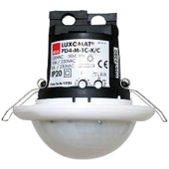
Degree / protection class: SM: IP54 with base, FC: IP20/Class II/CE
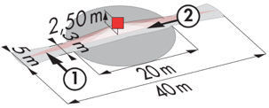
Detection area: h=2,50 m: 40 x 5 m across, 20 x 3 m towards, Ø 8 m vertical
Switching power: 2300W cos φ 1/1150VA cos φ 0.5, LED 300W maxi
Follow-up time: 30 s to 30 min or pulse / Brightness: 10 to 2000 Lux
Permanent control of daylight and artificial light
Applications: Circulations

Typical detector PD4-M-1C + Slaves in ceiling mounting (recessed or surface-mounted depending on the nature of the ceiling) of the BEG LUXOMAT brand or technically equivalent and will have the following characteristics:
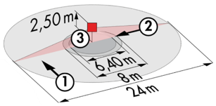
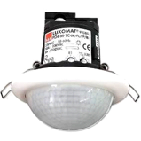
Degree / protection class: SM: IP54 with base, FC: IP20/Class II/CE
Detection area: h=2,50 m: Ø 24 m across, Ø 8 m towards, Ø 6,40 m activity seat
Switching power: 2300W cos φ 1/1150VA cos φ 0.5, LED 300W maxi
Follow-up time: 30 s to 30 min or pulse / Brightness: 10 to 2000 Lux
Permanent control of daylight and artificial light
Applications: Halls / Waiting area

LC Plus 280° wall-mounted detector of the brand BEG LUXOMAT or technically equivalent and will have the following characteristics:

Degree / protection class: IP54/Class II/CE
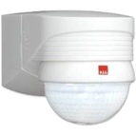
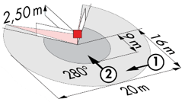
Detection area: h=2,50 m: 16 m across, 9 m towards, 2 m vertical
Switching power: 2000W cos φ 1/1000VA cos φ 0.5, LED 250W maxi
Follow-up time: 15 s to 16 min or pulse / Brightness: 2 to 2500 Lux
Applications: Stair

2- Small rooms Management:
Automatic operation by presence and luminosity detector

Detector type PD3N-1C for ceiling mounting (flush-mounted or surface-mounted depending on the nature of the ceiling) of the brand BEG LUXOMAT or technically equivalent and will have the following characteristics:

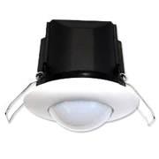
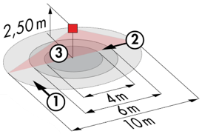
Protection class: SM: IP44, FC: IP23/Class II/CE
Detection area h=2.50 m: Ø 10 m across, Ø 6 m towards, Ø 4 m activity seat
Switching power: 2300W cos φ 1/1150VA cos φ 0.5, LED 300W max
Follow-up time: 30 s to 30 min or pulse / Brightness: 10 to 2000 Lux
Applications: Sanitary / Cloakrooms / Technical rooms / Airlocks...

3- Office Management:
Semi-automatic operation by absence detector on DALI dimmable luminaires. The lighting will be switched on manually and voluntarily by pressing a button. Only dimming, considering natural light, and switching off will be automatic. The PB will also allow the user to manually control the lighting, enabling him to temporarily force the lighting to be switched on, off and dimmed.

Detector type PD4N-M-DACO-DALI 2 + Slaves for ceiling mounting (recessed or surface mounting depending on the nature of the ceiling) of the brand BEG LUXOMAT or technically equivalent and will have the following characteristics:

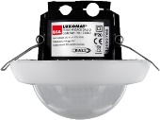
Protection class: SM: IP54 with surface-mounted accessory, FC: IP20/Class II/CE
Detection area h=2.50 m: Ø 24 m across, Ø 8 m towards, Ø 6,40 m seated
Interface: DALI 2 certified, digital driver control in broadcast mode
Follow-up time: 1 to 150 min or pulse / Brightness: 10 to 2500 Lux
Daylight-dependent constant dimming / 40 digital DALI drivers
Settings: Via bi-directional BEG-One smartphone application (read/write)
Applications: Offices

4- Operating principles of the rooms:
- Bathroom management
Automatic operation by presence and luminosity detector IP65
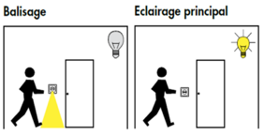
- Orientation lighting management
Automatic operation by presence and luminosity detector. The beaconing will allow the nurse carrying out his rounds or the resident to bring an orientation light in case of detection
- Entrance lighting management
Semi-automatic operation by absence and luminosity detector. A push button, integrated in the detector, will allow the entrance lighting to be switched on manually and voluntarily. Only the extinction will be automatic

Detector type PD9-M-1C-IP65-FC for flush ceiling mounting, brand BEG LUXOMAT or technically equivalent, with the following characteristics:
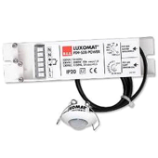
Protection class: Detection head: IP65/Class III/CE, Power supply IP20/Class II/CE
Detection area h=2.50 m: Ø 10 m across, Ø6 m towards, Ø4 m seated
Switching power: 2300W cos φ 1/1150VA cos φ 0.5, LED 300W max
Follow-up time: 15 s to 30 min or pulse / Brightness: 10 to 2000 Lux
Application: Bathrooms / Showers

Detector type Indoor 140L for wall flush mounting, installation height 1.10 m of the brand BEG LUXOMAT or technically equivalent and will have the following characteristics:
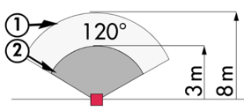
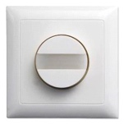
Protection class: FM: IP20/Class II/CE,
Detection zones h=1.10 m: 8 m across, 3 m towards
Switching power: 2000W cos φ 1/1000VA cos φ 0.5, LED 250W max
Follow-up time: 15 s to 30 min or pulse / Brightness: 10 to 2000 Lux
Functions: Beaconing / Night light. Integrated push button for manual control of the lighting
Application: Orientation lighting / Entrance lighting

5- Exhibition management
Semi-automatic operation by absence detector on DALI dimmable luminaires with Tunable White equipped with "DT8" type drivers. The lighting management system will ensure a change in color temperature of the luminaires to reproduce the natural cycle of the sun, "Circadian" biodynamic lighting. The lighting near the windows will be controlled independently of the lighting on the corridor side, allowing for natural light. The lighting will be switched on manually and voluntarily by pressing a button. Only the variation, considering the natural light, the change of color temperature and the extinction will be automatic. The system will also allow users to temporarily control switching on and off and dimming, but not to change the color temperature.

Detector type PD4-M-HCL2 with "Tunable White" function + Slaves in ceiling mounting (flush or surface mounted depending on the nature of the ceiling) of the brand BEG LUXOMAT or technically equivalent and will have the following characteristics:
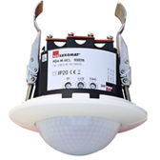
Protection class: SM: IP54 with base, FC: IP20/Class II/CE
Detection area h=2.50 m: Ø 24 m across, Ø 8 m towards, Ø 6,40 m seated
Presence detector with: Power supply, DALI BUS controller and HCL
Real time clock
DALI zone segmented into 3 groups with constant offset control (Groups 1 to 3)
Follow-up time: 5 to 120 min or pulse / Brightness: 10 to 2000 Lux
Daylight-dependent constant dimming / 64 DALI DT8 digital drivers
Applications: Lounges

