LIGHTING CONTROLS

Generally, the lighting will be controlled by presence and luminosity detectors. The type, number, brightness, and time settings of the detectors shall be adapted to the premises and the lighting sources being controlled. The circuits shall be properly subdivided so that only dark areas are lit during the day. All detectors shall be adjustable by remote control

Principles of operation and material requirements

1- Small premises Management:
Automatic operation by presence and luminosity detector

Detector type PD3N-1C for ceiling mounting (flush-mounted or surface-mounted depending on the nature of the ceiling) of the brand BEG LUXOMAT or technically equivalent and will have the following characteristics:

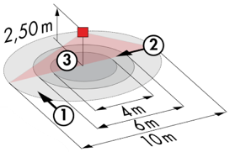
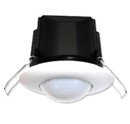
Protection class: SM: IP44, FC: IP23/Class II/CE
Detection area h=2.50 m: Ø 10 m across, Ø 6 m towards, Ø 4 m activity seat
Switching power: 2300W cos φ 1/1150VA cos φ 0.5, LED 300W max
Follow-up time: 30 s to 30 min or pulse / Brightness: 10 to 2000 Lux
Applications: Sanitary / Cloakrooms / Technical rooms / Airlocks...

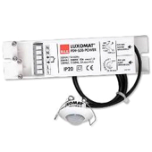
Detector type PD9-M-1C-IP65-FT for flush ceiling mounting, brand BEG LUXOMAT or technically equivalent, with the following characteristics

Protection class: Detection head: IP65/Class III/CE, Power supply IP20/Class II/CE
Detection area h=2.50 m: Ø 10 m across, Ø 6 m towards, Ø 4 m seated
Switching power: 2300W cos φ 1/1150VA cos φ 0.5, LED 300W max
Follow-up time: 15 s to 30 min or pulse / Brightness: 10 to 2000 Lux
Application: Showers

2- Technical management of the building:
The building will be equipped with a GTB allowing the control of various technical units either by local, automatic, or centralized controls. The system will ensure modularity of operation according to the activities carried out, conference, projection, etc., and should be scalable to anticipate a possible extension to new installations. The principle will be based on a KNX BUS. Commissioning and modifications will be carried out via the dedicated programming software "ETS", connected locally via a KNX/IP interface or via a WEB interface on the LAN or WLAN network and will be carried out by a KNX certified integrator. The system will allow, via a supervision, a complete control of the installations, a visualization of the status and the reception of information for maintenance.

Via the components connected to the BUS, this solution will provide the following functions:

2.1- Lighting Management
A lighting management system will be installed in each lecture theatre, allowing the light sources to be completely switched off when unoccupied or when there is sufficient natural light in the room. The system will be composed of presence sensors, digital switching TOR or DALI dimming actuators depending on the nature of the luminaires, associated with a "KNX" type control panel.

Gymnasium and Sports Hall Management
- Occupancy management by absence detection - Lighting by control panel, not accessible to the public
- Variable lighting, constant lighting threshold for training thresholds only
- Fixed thresholds, without lighting regulation for competition
- Modularity according to the activities practiced, ½ field or full field, management of a climbing wall...
- Forcing of status by the GTB

In the corridors (corridors, staircases, etc.)
- Occupancy management by presence and luminosity detection.
- Forcing of state possible by the GTB

2.2- Air change management
The air renewal of each room will be controlled automatically, considering the occupation of the room and the quality of the ambient air. Information on room occupancy will be sent to the HVAC package via presence sensors.

2.3- Temperature management
Each room will be equipped with a temperature sensor and a presence sensor, associated with a weather station and an annual time circuit according to the occupation of the building. The temperature of each room can be adapted to the information retrieved on the KNX bus (temperature increase in advance in case of extreme cold, reduced temperature at night…).

2.4- Control panel
The local management of the various technical packages will be controlled either by a control panel or by means of a touch screen that groups together the different lighting levels, depending on the activities and the level practiced, the forcing of the temperature set point and the control of the ventilation. The control panel shall not be accessible to the public or, if a touch screen, protected by a security code.

The KNX system selected will be of the brand BEG LUXOMAT or technically equivalent, comprising the following equipment

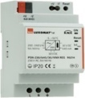
- KNX power supply type PSN-230/640/30-KNX-REG
230V AC / 30V DC BUS KNX / 640mA/ 1000m BUS max
Integrated choke to supply the bus with constant and stabilized current
Up to 64 participants on the KNX BUS (Multi-sensors / PB interfaces / Actuators…)

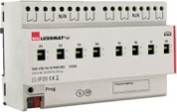
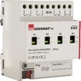
- Switching actuator “TOR” type SA4/8/230/16/H/KNX REG
Power supply via KNX BUS
Outputs: 4 (SA4) or 8 (SA8) 16 A switching outputs
Current measurement possible with actuator type SA4/8-230/16/H/EM/KNX REG
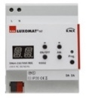
- DALI/KNX Gateway type DA64-230/KNX REG
Power supply 230V AC – Communication via KNX BUS
DALI BUS supply for 64 luminaires in 16 groups / 16 scenes
Support for RGB and TW (Tunable White – DALI Type 8)

- KNX multi-sensor type PDx-KNX-BA/ST/DX
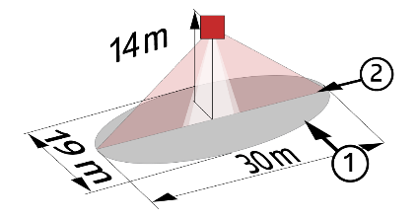
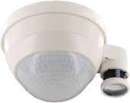
Power supply and communication via KNX BUS

PD4-KNX-C SM/FC/FM (DX): 40 x 5 m across, 20 x 3 m towards, Ø 8 m vertical
Applications: Circulation
PD4-KNX SM/FC/FM (BA-ST-DX): Ø24 m across, Ø8 m towards, Ø6,40 m seated
Applications: Sports halls / Halls
RC-plus 230 KNX (DX): 20m across, 6m face, 4m vertical
Applications: Stairs
PD4-KNX-GH SM (DX): Ø 30 x Ø19 m towards
Applications: Gymnasium
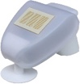
- KNX Weather Station type KNX-WTS-GPS
Power supply and communication via KNX BUS
Wind, Rain, Dusk, Temperature and Light Sensors

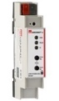
- KNX Router and IP interface
Power supply and communication via KNX BUS
Router LK-IP/KNX-REG: Enables the transfer of telegrams between different KNX segments via a LAN (IP)
LAN-IF/KNX-REG IP interface: Connection of a PC for addressing via LAN bus, programming, and diagnostics of KNX components

