LIGHTING CONTROLS

Generally, lighting management will be carried out by presence and brightness detectors. The type, the number, the brightness, and time delay adjustment values ​​will be adapted to the premises and to the controlled lighting sources. Circuits will be properly subdivided so that only dark areas are lit during the day. All detectors must be adjustable by remote control.

Principles of operation and material requirements

1- Circulation, Halls, Stairwells Management:
Automatic operation by presence and luminosity detector on 2/3 of the lighting, 1/3 on a control system not accessible to the public allowing compliance with EC6.1 regulations

Typical detector PD4-M-1C-Corridor + Slaves in ceiling mounting (recessed or surface-mounted depending on the nature of the ceiling) of the BEG LUXOMAT brand or technically equivalent and will have the following characteristics:
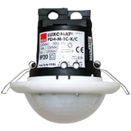
Degree / protection class: SM: IP54 with base, FC: IP20/Class II/CE
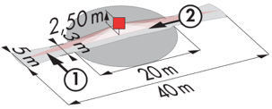
Detection area: h=2,50 m: 40 x 5 m across, 20 x 3 m towards, Ø 8 m vertical
Switching power: 2300W cos φ 1/1150VA cos φ 0.5, LED 300W maxi
Follow-up time: 30 s to 30 min or pulse / Brightness: 10 to 2000 Lux
Permanent control of daylight and artificial light
Applications: Circulations

Typical detector PD4-M-1C + Slaves in ceiling mounting (recessed or surface-mounted depending on the nature of the ceiling) of the BEG LUXOMAT brand or technically equivalent and will have the following characteristics:
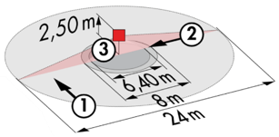
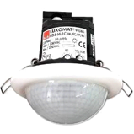
Degree / protection class: SM: IP54 with base, FC: IP20/Class II/CE
Detection area: h=2,50 m: Ø 24 m across, Ø 8 m towards, Ø 6,40 m activity seat
Switching power: 2300W cos φ 1/1150VA cos φ 0.5, LED 300W maxi
Follow-up time: 30 s to 30 min or pulse / Brightness: 10 to 2000 Lux
Permanent control of daylight and artificial light
Applications: Halls

LC Plus 280° wall-mounted detector of the brand BEG LUXOMAT or technically equivalent and will have the following characteristics:

Degree / protection class: IP54/Class II/CE
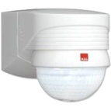
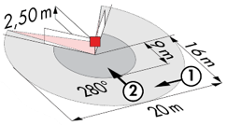
Detection area: h=2,50 m: 16 m across, 9 m towards, 2 m vertical
Switching power: 2000W cos φ 1/1000VA cos φ 0.5, LED 250W maxi
Follow-up time: 15 s to 16 min or pulse / Brightness: 2 to 2500 Lux
Applications: Stair / Outdoor

2- Small rooms Management:
Automatic operation by presence and luminosity detector

Detector type PD3N-1C for ceiling mounting (flush-mounted or surface-mounted depending on the nature of the ceiling) of the brand BEG LUXOMAT or technically equivalent and will have the following characteristics:

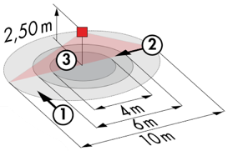
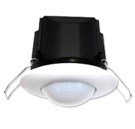
Protection class: SM: IP44, FC: IP23/Class II/CE
Detection area h=2.50 m: Ø 10 m across, Ø 6 m towards, Ø 4 m activity seat
Switching power: 2300W cos φ 1/1150VA cos φ 0.5, LED 300W max
Follow-up time: 30 s to 30 min or pulse / Brightness: 10 to 2000 Lux
Applications: Sanitary / Cloakrooms / Technical rooms / Airlocks...

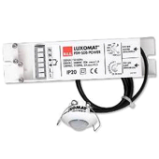
Detector type PD9-M-1C-IP65-FT for flush ceiling mounting, brand BEG LUXOMAT or technically equivalent, with the following characteristics

Protection class: Detection head: IP65/Class III/CE, Power supply IP20/Class II/CE
Detection area h=2.50 m: Ø 10 m across, Ø 6 m towards, Ø 4 m seated
Switching power: 2300W cos φ 1/1150VA cos φ 0.5, LED 300W max
Follow-up time: 15 s to 30 min or pulse / Brightness: 10 to 2000 Lux
Application: Showers

3- Gymnasium and Sports Hall Management:

Semi-automatic operation by absence detector on DALI dimmable luminaires. The lighting will be switched on manually and voluntarily by a control panel, not accessible to the public. Only dimming, considering natural light, and switching off will be automatic. The control panel will allow different lighting thresholds to be set according to the activities and the level of use and will allow the light sources to be completely switched off.
Commissioning and modifications will be carried out via a dedicated Smartphone application in BLE (Bluetooth) communication with the system. It will be the responsibility of the contractor or the manufacturer's commissioning service.

The lighting management system will provide the following functions:
- Training threshold 200/300 lux - Constant regulation to take account of natural light
- Competition threshold - 400/500 lux - Fixed threshold without regulation
- Total extinction command

The chosen principle will be the DALILINK brand BEG LUXOMAT or technically equivalent comprising the following equipment:

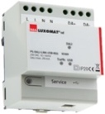
- DALI BUS Power Supply type PS-DALILINK-USB-REG-210mA with the following characteristics:
230V AC mains supply / DALI BUS power supply 16V DC / 210mA / 300m BUS max
Self-addressing of the components on the BUS
Control of up to 45 DALI luminaires and 10 control devices
(Multi sensors/ PB interfaces...)
Up to 8 control zones per supply / 16 groups / 16 scenes
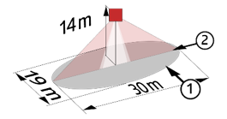
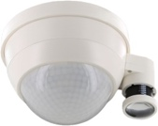
- DALI Multi-sensor type PD4-DALILINK-GH-SM with the following features:
Power supply and communication via DALI BUS 16V DC
Protection class: SM: IP54/Class II/CE
Detection area h=10 m: Ø 30 x Ø 19 m towards

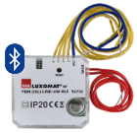
- DALI PB interface type PBM-DALILINK-4W-BLE with the following features:
Power supply and communication via DALI BUS 16V DC
Bluetooth communication for parameterization
4 binary inputs can be interfaced independently
Can be combined with all manufacturers' pushbuttons
Version without Bluetooth: PBM-DALILINK-4W

