LIGHTING CONTROLS

Generally, lighting management will be carried out by presence and brightness detectors. The nature of the detectors, the number, the brightness, and time delay adjustment values ​​will be adapted to the premises and to the controlled lighting sources. Circuits will be properly subdivided so that only dark areas are lit during the day. All detectors must be adjustable by remote control.

Principles of operation and material requirements

1- Small Rooms Management:
Automatic operation by presence and light sensor

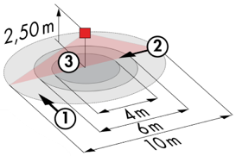
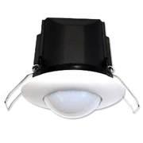
Typical detector PD3N-1C for ceiling mounting (recessed or surface-mounted depending on the nature of the ceiling) of the BEG LUXOMAT brand or technically equivalent and will have the following characteristics:

Degree / protection class: IP44, FC: IP54/Class II/CE
Detection area: h=2,50 m: Ø 10 m across, 6 m towards, 4 m activity seat
Switching power: 2300W cos φ 1/1150VA cos φ 0.5, LED 300W maxi
Follow-up time: 30 s to 30 min or pulse / Brightness: 10 to 2500 Lux
Applications: Toilets / Lockers rooms / Equipment rooms / Airlocks…

2- Management of Offices, Conference Rooms, Corridors and Stairways:
The lighting management will be based on DALI2 technology, according to IEC 62386 standard. The DALI bus will be used to connect luminaires and presence detectors via controllers or bus interfaces connected to the BMS. The management system will automatically dim the lighting to consider the natural light inflow and will allow the light sources to be completely switched off when unoccupied. This solution will offer the possibility of easily modifying the partitions, without intervention on the luminaires or the wiring, and will have to be evolutionary allowing to anticipate a possible extension to new installations. Each luminaire will be addressed individually, to report the status and defects of each device to the supervision system.

Through the components connected to the BUS, this solution will provide the following characteristics:

2.1- Office Management
- Occupancy management by absence detection / Lighting variation, constant lighting threshold
- User" overrides by local PB
- Control of air renewal and temperature by information from the presence sensors to the HVAC unit
- BMS link

2.2- Conference Room Management
- Occupancy management by absence detection / Lighting variation, constant lighting threshold
- Lighting segmented into a minimum of 3 groups: Window side management, corridor side management and Table or Screen
- User" overrides by control panel not accessible to the public
- Creation of a projection scenario: Switching off the board or screen lighting, lowering the room's lighting to 10%.
- Control of air exchange and temperature by informing the HVAC package of presence sensors
- BMS link

2.3- Management of Circulation, Halls and Stairwells
- Occupancy management by presence and luminosity detection
- Lowering to the minimum regulatory threshold in the event of unoccupation
- In the stairwells, this solution will ensure level by level operation
- BMS link

The selected sensors will be " Multi-Master " on DALI 2 protocol of BEG LUXOMAT brand or technically equivalent and will have the following technical characteristics:

- Multi-sensor DALI type PDx-BMS-DALI2
DALI Multi-Master technology according to IEC 62386, part 103
Compatible with DALI 2 controllers according to IEC 62386 part 101/103/304. Section 0 provides information on room assignment and motion detection on the DALI bus according to IEC 62386 part 303. Section 1 provides the LUX values on the DALI bus according to IEC 62386 part 304. Parameterization is possible via a multi-master application controller from any manufacturer on DALI 2 protocol.

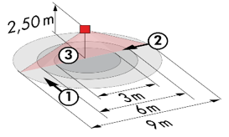
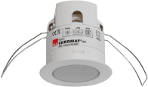
PD11-BMS-DALI2-FC: Ø 9 m across, Ø 6 m towards, Ø 3 m seated
Applications: Offices
PD4N-BMS-DALI2-SM/FC: Ø 24 m across, Ø 8 m towards, Ø 6,40 m seated
Applications: Meeting rooms / Halls
PD4N-BMS-DALI2-C SM/FC: 40 x 5 m across, 20 x 3 m towards, Ø 8 m vertical
Applications: Circulation
LC-Mini-120°-BMS-DALI2: 12 m across, 3 m towards
Applications: Stairs

